AIDI 1005 : WEEK 1

Q1: Which is an important element in textual analysis

a dictionary

Q2: What are the two types of knowledge?

declarative and procedural

Q3: Which object characteristic is used in image recognition?

all of these answers

Q4: -------------- use rules to evaluate and reach conclusions about problems based on data in a very specific domain or area.

Expert Systems

Q5: Natural _____ processing is an area of AI

Language

WEEK 3

Question 1:What Cassandra component maps from partition keys to nodes in a cluster?

User defined hash function

Question 2: Which replication strategy is used to replicate data across data centers?

Network Topology Strategy

Question 3: Cassandra implements high availability using multiple servers in a cluster.

True

Question 4: Secondary indexes can be used effectively with low and high cardinality columns?

False

Question 5: A keyspace is the highest level data structure in a Cassandra cluster.

True

WEEK 4

Q1: Which of the following will complete the statement on line 1 to add three new items to the 'fruit' table?

INSERT INTO fruit VALUES

Q2: Tables can be found in which collection of database objects?

Schemas

Q3: In a complete PostgreSQL environment, the _____ stores and manages data and the _____ is used to connect and work with data

server, client

Q4: What is the name of the default user?

postgres

Q5: What character does PostgreSQL use to terminate a command?

semicolon ( ; )

Data Science Process Lifecycle

Now as we know data is of utmost importance in AI, so lets spend some time to understand the Data Science Process Lifecycle for the next few minutes. Step one in any business problem where we hope to apply AI is just having the right data and having that data cleaned up and organized.

If your data's not in good shape, AI tools are likely to be worse than useless. As a matter of fact, you're likely to end up with inaccurate conclusions.

A key driver of the rise of the so-called data-driven organization is the increased awareness and use of data-driven decision-making (DDD) at all levels of the business. This is in large part because of the increasing availability and quality of collected data, as well as increasing opportunities to make use of it. As Data Science and AI make their way into almost every industries under the sun, so do the challenges of building a team capable of building successful AI projects. The demand for that archetypical “Data Scientist” who is the perfect blend of a statistician, programmer and communicator has never been greater. But as the dust settles, we have started hearing stories of failed projects and disenchanted professionals.

Modern data science teams recognize enlisting business partners in a shared collaboration is essential for delivering business value. They also recognized that too many analytics models are not deployed, or don’t deliver the expected business value. Data science teams are adopting decision modeling to address these gaps.

As a data science consultant who has worked in various industries, I’ve had the chance to see this trend firsthand. Many people tend to think Data Science as a new field and expect it to have growing pains as it becomes mainstream, but we forget where this field came from. In the coming videos we reflect on the qualities that make a successful data team and help business leaders and executives create better AI strategies. We will also learn how to think like a data scientist, including taking the steps involved in tackling a data science problem and applying them to interesting, real-world examples. So lets see What is Data Science?



Data Scientist: The Sexiest Job of the 21st Century - This title has been around for a few years now. I love my job as a Data scientist, but is it the sexiest job out there. Hmmm.... I love being a data scientist, its challenging and fun. But about the sexiest part, not so sure. So in this part you will be learning about the methodology which is very close to real world experience of working as a data scientist. You will learn how to work on a data science project from developing an idea to deploying it and all the steps in between.

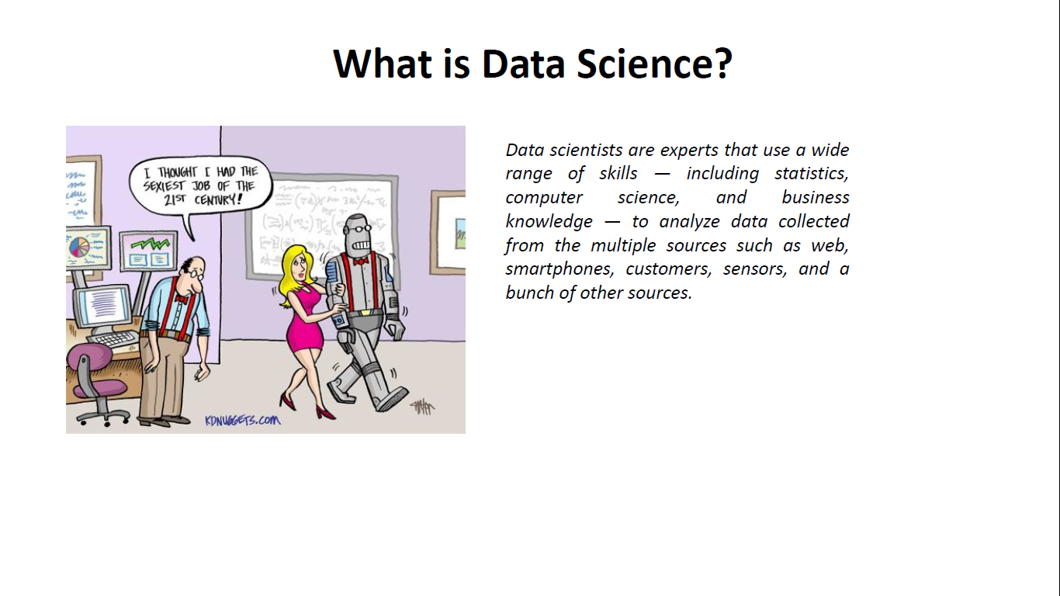

The term “data scientist” came into existence sometime around 2008, when companies began to realize the need for professionals, expert at understanding and dealing with data. These professionals could be ranging anywhere from your garden variety statisticians to PhD’s. In my opinion, what makes this field particularly interesting is, its ability to combine, not only the hard sciences of math, statistics and computer science but also the importance of domains such as biology, healthcare, finance, economics, sociology and the list goes on.

So in simple words, **Data Science is a versatile field that uses scientific methods, processes, algorithms, and systems to extract value from data.**

**Now, let's look at What’s a Data scientist? Data scientists are experts that use a wide range of skills — including statistics, computer science, and business knowledge — to analyse data collected from the multiple sources such as web, smartphones, customers, sensors, and a bunch of other sources.**

**The idea is to reveal trends and produce insights that businesses can use to make better decisions and create more innovative products and services.**

Data Science is a versatile field that uses scientific methods, or algorithms with the use of wide range of skills — including statistics, computer science, and business knowledge — to analyse data collected from the multiple sources such as web, smartphones, customers, sensors, and a bunch of other sources. The idea behind data sceintist is to extract the important features of the data and reveal trends and produce insights from the imported data.

Just businesses, you ask? Absolutely not; data is the bedrock of innovation and its value comes from the information, data scientists can glean from it and then act upon. The role of Data Scientists has become quite important to businesses. Data scientists can be real change-makers within an organization, offering insight that can illuminate the company’s trajectory toward its ultimate business goals.



Data scientists are integral to supporting both leaders and developers in creating better products and paradigms. And as their role in big business becomes more and more important, they are in increasingly short supply.

In terms of credentials, it’s not uncommon for a data scientist candidate to have a PhD but its not mandatory. Beyond educational credentials, they are expected to use professional skills such as communication, leadership, collaboration, creativity, discipline, and a driving passion for truth in information.

A typical day of a Data Scientist at work includes communicating with business stakeholders, to understand their goals, and determine how data can be used to achieve those goals.

They design data modeling processes, create algorithms and predictive models to extract the insights the business needs, the findings are then shared with peers gained from analyzing the data. While each project is different, the process for gathering and analyzing data generally follows the below path:

1. Ask the right questions to begin the discovery process
2. Acquire data, Process it and clean it.
3. Integrate and store data
4. Perform some Initial data investigation and exploratory data analysis.

Choose one or more potential models and algorithms and Apply data science techniques, such as machine learning, statistical modeling, and artificial intelligence. The final stage is where we Measure and improve results, Present final result to stakeholders, Make adjustments based on feedback and Repeat the whole process to solve a new problem.

This is what we are going to focus on in this section, the Data Science Process Lifecycle, it's a recommended lifecycle that you can use to structure your data-science/AI/ML projects.

The Data Science Process lifecycle is basically a step by step framework/structure that you can use to complete your data-science projects successfully. This lifecycle is designed for data-science projects that are intended to ship as part of intelligent applications.



These applications deploy machine learning or artificial intelligence models for predictive analytics. Data science Process Lifecycle can explore historical data,

make comparisons to competition, analyze the market, and ultimately, make recommendations of when and where your product or services will sell best. This can help a company understand how their product helps others and optimize existing business processes.

Imagine that you are a Data Scientist and your first job is to increase sales for a company. The company wants to know what product they should sell in what period. You will need a framework, a structure to organize your work, analyze different types of data, and solve their problem. Your customer doesn’t care about how you do your job; they only care about the end result.

Often there's a temptation to bypass the process and jump directly to solutions. Doing so however, hinders our best intentions in trying to solve the problem. This course has one purpose and that is to share a process that can be used to ensure that the data used in problem solving is relevant and properly manipulated to address the question at hand. So, the question arises why Data Science Process LifeCycle is important? When working with big data, it is always advantageous for data scientists to follow a well-defined data science workflow.

Regardless of whether a data scientist wants to perform analysis, with the motive of conveying a story through data visualization or wants to build a data model- the data science workflow matters. **Having a standard workflow for projects ensures that the various teams within an organization are in sync, so that any delays can be avoided**. The end goal of any data science project is to produce an effective data product. The key insights gathered at the end of a data science project is referred to as a data product. A data product can be anything -a dashboard, a recommendation engine or anything that facilitates business decision-making) to solve a business problem.

However, to reach the end goal of producing data products, data scientists have to follow a formalized step by step workflow.

Next, you will learn how to think like a data scientist, including taking the steps involved in tackling a data science problem and applying them to interesting, real-world examples. You will learn methodical ways of moving from problem to approach, including the importance of understanding the question, the business goals and objectives, and picking the most effective analytic approach to answer the question and solve the problem. You will also learn systematic ways of working with the data, specifically, determining the data requirements, collecting the appropriate data, understanding it, and then preparing it for modeling!



You are going to learn how to model the data by using the appropriate analytic approach, based on the business requirements and the problem that you were trying to solve. Once the approach is selected, you will learn the steps involved in evaluating and deploying the model, getting feedback on it, and using that feedback constructively so as to improve the model. The success of any data science project will depend on how closely we follow the process. So next we will cover the first step of the Data Science Process Lifecycle that is **Business Understanding**. You will see how important it is to have a business understanding

1. **Business Understanding**

“Give me data and I can do wonders” … This is a common fallacy we see today among data scientists.

Many data scientists today miss a crucial step of understanding the business and how underneath data was generated from the business process before playing around with data. While jumping on to, data is not bad all the time but in most of cases, we end up with insights that do not get integrated with real-world instances. Business understanding is very important before jumping in, there are multiple pitfalls of not having an understanding of business and underneath data, such as Trying to solve business objectives other than actual one can impact the business significantly.

Insights that do not generate any significant value even after it gets into production Business and Data Scientist acting in a complete vacuum often result in business deployment skew.

To state an example, I knew a marketing team who had a problem with low conversion rates (< 14 %) for acquiring new prospects. They were also spending a high cost to acquire prospects that were taking more time for them to turn positive post prospects into their customers. The Data Scientist team got internal CIO funding and related datasets to solve the problem. So here is how it went wrong, Business stakeholders were consulted minimally to clarify data elements rather than understanding the business process or real challenges within the business environment.



The resultant model that was developed did slightly better than the current conversion rate in the validation phase. Excited CIO and Data Scientist team put this finding forward to Business explaining what they did. Turned out the marketing team challenge was not low conversion rate, while they would love to increase conversion rate their immediate problem was not able to prioritize prospects to understand where to spend more and where not.

There was a lack of customization to individual prospects in terms of products or offers. Coming to the point by not working on clear business objective or agreeable success criteria, the data science project has already failed before it even started.

In business understanding phase we basically: Define goals We Specify the key variables that are to serve as the model targets and whose related metrics are used to determine the success of the project. We Identify the relevant data sources that the business has access to or needs to obtain.

So the next question is,

**how to do define goals**

There are two main tasks addressed in this stage:

**Define objectives**: Here we Work with your customer and other stakeholders to understand and identify the business problems. We Formulate questions that define the business goals that the data science techniques can target. A central objective of this step is to identify the key business variables that the analysis needs to predict.

We refer to these variables as the model targets, and we use the metrics associated with them to determine the success of the project. Two examples of such targets are **sales forecasts** or the **probability of an order being fraudulent**.

We Define the project goals by asking and refining "sharp" questions that are relevant, specific, and unambiguous. Data science is a process that uses names and numbers to answer such questions. You typically use data science or machine learning to answer five types of questions:

How much or how many? (regression)

Which category? (classification)

Which group? (clustering)

Is this weird? (anomaly detection)

Which option should be taken? (recommendation)

So the first thing you have to do after the objective is set as per business understanding, determine which of these questions you're asking and how answering it achieves your business goals. And then Define/create the project team by specifying the roles and responsibilities of its members.

Develop a high-level milestone plan that you iterate on as you discover more information. Once team, role and responsibilities are discussed, Define the success metrics. For example, you might want to achieve a customer churn prediction. You need an accuracy rate of "x" percent by the end of this three-month project.

With this data, you can offer customer promotions to reduce churn. The metrics must be SMART:

**S**pecific

**M**easurable

**A**chievable

**R**elevant

**T**ime-bound

And then comes data into the picture, not actual data but identifying the data sources. Here we find the relevant data that helps you answer the questions that define the objectives of the project. We Look for Data that's relevant to the question. We see if we have measures of the target and features that are related to the target?

Here are some of the deliverables at this stage:

**Charter document**: The charter document is a living document. You update the template throughout the project as you make new discoveries and as business requirements change. The key is to iterate upon this document, adding more detail, as you progress through the discovery process. Keep the customer and other stakeholders involved in making the changes and clearly communicate the reasons for the changes to them.

**Data sources Report**: The Raw data sources report specifies the original and destination locations for the raw data. In later stages, you fill in additional details like the scripts to move the data to your analytic environment.

**Data dictionaries**: This document provides descriptions of the data that's provided by the client. These descriptions include information about the schema (the data types and information on the validation rules, if any) and the entity-relation diagrams, if available.

Thus, by working on having a sound business understanding, structured discussions can take place where priorities can be identified in a way that can lead to organizing and planning on how to tackle the problem. Depending on the problem, different stakeholders will need to be engaged in the discussion to help determine requirements and clarify questions.

So you might have gained a good understanding of how important this stage is for the success of your data science project. Having a business understanding of the problem and identifying data sources are two important things which we discussed in this video.

**2. Analytic approach**

Next, we are going to look at the next stage in the lifecycle which is analytic approach. You know the business problem and questions. Now the next stage is, Analytics Approach:

How can you use the data to answer the question? Selecting the right analytic approach depends on the question being asked. Once the problem to be addressed is defined, the appropriate analytic approach for the problem is selected in the context of the business requirements.

This is the second stage of the data science process lifecycle. This step entails expressing the problem in the context of statistical and machine-learning techniques, and it is essential because it helps identify what type of patterns will be needed to address the question most effectively. The analytical options may include:-

1. Statistical analysis applies to problems that require counts
2. If the question is to determine probabilities of an action, then a predictive model might be used.
3. If the question is to show relationships, a descriptive approach maybe be required.
4. If the question requires a yes/ no answer, then a classification approach to predicting a response would be suitable.

Let's look at a simple example, suppose we have to classify the mails which we receive in our Email Id to spam and non-spam. So, the basic question is whether the mail received is a spam or not a spam. So, we shall use the classification model as it gives us the answer as yes or no. If the result comes as yes, the mail shall go to the spam folder and if no it shall be delivered as a normal mail in our Inbox.



There are 4 different types of analytics. Here, we start with the simplest one and go further to the more sophisticated types. As it happens, the more complex an analysis is, the more value it brings. **Descriptive analytics**

Descriptive analytics answers the question of what happened. Let us see an example: having analyzed monthly revenue and income per product group, and the total quantity of metal parts produced per month, a manufacturer was able to answer a series of ‘what happened’ questions and decide on focus product categories. Descriptive analytics juggles raw data from multiple data sources to give valuable insights into the past. However, these findings simply signal that something is wrong or right, without explaining why.

For this reason, data consultants don’t recommend highly data-driven companies to settle for descriptive analytics only, they’d rather combine it with other types of data analytics.

**Diagnostic analytics**

At this stage, historical data can be measured against other data to answer the question of why something happened. For example, a retailer can drill the sales and gross profit down to categories to find out why they missed their net profit target. Another example in the healthcare industry would be customer segmentation coupled with several filters applied (like diagnoses and prescribed medications) allowed identifying the influence of medications. Diagnostic analytics gives in-depth insights into a particular problem. At the same time, a company should have detailed information at their disposal, otherwise, data collection may turn out to be individual for every issue and time-consuming.

**Predictive analytics**

Predictive analytics tells what is likely to happen. It uses the findings of descriptive and diagnostic analytics to detect clusters and exceptions, and to predict future trends, which makes it a valuable tool for forecasting. For eg we can help a leading FMCG company to predict what they could expect after changing brand positioning. Predictive analytics belongs to advanced analytics types and brings many advantages like sophisticated analysis based on machine or deep learning and proactive approach that predictions enable. However, forecasting is just an estimate, the accuracy of which highly depends on data quality and stability of the situation, so it requires careful treatment and continuous optimization.

**Prescriptive analytics**

The purpose of prescriptive analytics is to literally prescribe what action to take to eliminate a future problem or take full advantage of a promising trend. An example of prescriptive analytics: A multinational company was able to identify opportunities for repeat purchases based on customer analytics and sales history. Prescriptive analytics uses advanced tools and technologies, like machine learning, business rules and algorithms, which makes it sophisticated to implement and manage. Besides, this requires not only historical internal data but also external information due to the nature of algorithms it’s based on. That is why, before deciding to adopt prescriptive analytics, We strongly recommend weighing the required efforts against an expected added value.

**3. Data Requirements.**

So next we will cover the 3rd stage of the Data Science Process Lifecycle that is Data Requirements. You will see how important to discover the correct data for our model. So previously we have understood the Analytic approach, and how certain problems require certain analytic approaches to be applied. If your goal is to make a spaghetti dinner but you don't have the right ingredients to make this dish, then your success will be compromised. Think of this section of the data science methodology as cooking with data. Each step is critical in making the meal. So, if the problem that needs to be resolved is the recipe, so to speak, and data is an ingredient, then the data scientist needs to identify:

which ingredients are required,

how to source or the collect them,

how to understand or work with them,

how to prepare the data to meet the desired outcome.

Building on the understanding of the problem at hand, and then using the analytical approach selected, the Data Scientist is ready to get started.

The data requirements analysis process employs **a top-down** approach that emphasizes business-driven needs, so the analysis is conducted to ensure the identified requirements are relevant and feasible. The process incorporates data discovery and assessment in the context of explicitly qualified business data consumer needs. Having identified the data requirements, candidate data sources are determined and their quality is assessed using the data quality assessment process.

Any inherent issues that can be resolved immediately are addressed using the approaches, and those requirements can be used for instituting data quality control. The data requirements analysis process consists of these phases:

1. Identifying the business contexts – This step includes 5 subparts

1. **identifying relevant stakeholders** - This is done through a review of existing system documentation or they may be identified by the data quality team through discussions with business analysts, enterprise analysts, and enterprise architects.
2. **Acquiring documentation**: In this step, the data quality analyst must become familiar with overall goals and objectives of the target information platforms to provide context for identifying and assessing specific information and data requirements.
3. **Documenting goals and objectives**: At this stage we Determine existing performance measures and success criteria that provide a baseline representation of high-level system requirements for summarization and categorization.
4. **Summarizing the scope of capabilities**: We Create graphic representations that convey the high-level functions and capabilities of the targeted systems, as well as providing details of functional requirements and target user profiles.
5. **Documenting impacts and constraints**: Constraints are conditions that affect or prevent the implementation of system functionality, whereas impacts are potential changes to characteristics of the environment to accommodate the implementation of system functionality.

Now, we move on to the next phase of Conducting stakeholder interviews Reviewing existing documentation only provides a static snapshot of what may (or may not) be true about the state of the data environment. A more complete picture can be assembled by collecting that might be deemed “hard evidence” from the key individuals associated with the business processes that use data. Therefore, our next phase is to conduct conversations with the previously identified key stakeholders, note their critical areas of concern, and summarize those concerns as a way to identify gaps to be filled in the form of data requirements.

The next phase synthesizes the results of the documentation scan and the interviews to collect metadata and data expectations as part of the business process flows so the analyst will review the downstream applications use of business information to identify named data concepts and types of aggregates and associated data element characteristics.

1. **Business Requirement**

The fourth is developing source to target mappings. The goal of source to target mapping is to climb is to clearly specify the source data elements that are used in downstream applications in most situations.

The consuming applications may use similar data elements from multiple data sources. The data quality analyst must determine, if any consolidation and or aggregation requirement are required and determine the level of atomic data needed for drill down. If necessary, any transformations specify how upstream data elements are modified for downstream consumption and business rules applied as part of the information flow. so during this phase the data analyst may identify the need for reference data sets this provides a good starting point in the data requirements analysis process that can facilitate the data selection process so with this the data requirement states for the data science process lifecycle ends now this brings us to the next step of data collection so now that we have a solid idea of our questions so it's time to define what data you need to find those answers so where is the data coming from and how to get it as a starting point you will want to determine if the data is readily available within your organization then ask yourself

* Do you have all the data that you need
* or you will need to externally source

If it's the latter then you might need to decide to run an experiment or conduct another survey whatever you choose the end goal of this step is to make sure that you have complete 360 degree view of the problem that you want to solve so where does this data come from we have two choices

* Observe the data from existing sources
* Generate the data via surveys simulations and experiments



Let's take a closer look at how both approaches work

The first approach is found or observed data to get this data from the internet. There are multiple options we can use bulk downloads from websites such as Wikipedia, imdb million song database etc, or we can access the data through api like apis for new york times twitter facebook foursquare or we can use web scripting to scrap public non-sensitive and anonymized data with humongous data only machines can get effective insights listening to huge streams of data from multiple sources at multiple infrastructure layers. Learning engine can discover trends and patterns and identify abnormalities the second approach would be to generate data.



An alternative approach is to generate data by yourself for example with a survey in a survey design we have to pay attention to data sampling that is who are the users completing the survey and we can only get the data from the users who are accessible and willing to respond also users can provide answers that are in line with self-image and researchers expectations next data can be collected using simulations where a domain expert specifies a behavior model of users at a micro level. For instance crowd simulation requires specifying how different types of users will behave in a crowd for example following the crowd looking for an escape etc the simulation can be run under different conditions to see what happens the process of generating data is often already established usually.

There is a monitoring tool plugged in collecting key performance indicators that we want to track. So if we want to generate additional data we need to invoke or write additional scripts measuring querying and logging them thus finding the data is not the problem the real challenge is which data to collect and how not to be overwhelmed by the useless noise collecting detailed metrics from the systems both on the application and infrastructure side 

Specialists need to look at tracking data from many sources it is important to understand the capabilities and limitations of each data source so that you can determine its applicability for your organization in gathering large volumes of data we need to leverage this data and build an adaptive system that is more proactive and less reactive the more the system can learn from the data the better it can identify variances and problem areas in a timely manner to help fix issues before it negatively impacts the business with poor performance or downtime

The data requirements and data collection stages are extremely important because the more relevant data you get the better you build your model. The more data collected at a detailed level the more accurate will be the predictions providing insights and inferences for a variety of use cases

so once the data ingredients are collected then in the data collection stage the data scientists will have a good understanding of what they will be working with.

1. **Data Understanding**

in the next stage we will see techniques such as descriptive statistics and visualizations can be applied to the data set to assess the content quality and initial insights about the data gaps. In data will be identified and plans to either fill or make substitutions will have to be made in a sense the ingredients are now sitting on the cutting board now that the data collection stage is complete data scientists use descriptive statistics and visualization techniques to understand data better but first let's see what is data understanding

Data understanding encompasses all activities related to constructing the data set essentially the data understanding section of the data science process life cycle answers the question is the data that you have collected representative of the problem to be solved data understanding is the knowledge that you have about the data the needs that the data will satisfy its content and its location to be clear it is much more than current location and a definition of what a data element means within an application or database

There is no tool or artifact for data understanding data understanding is expressed in organizations as business groceries data dictionaries models and other forms of metadata or other places where information about the data is stored in order to get to know our data better

we create a few reports like

we have the initial data collection report and here we list the data sets or data sources acquired together with their

* locations
* the methods used to acquire them
* and the problems encountered
* record problems encountered and any resolutions achieved

so this will aid with future replication of this project or with execution of similar future projects then we have the **data description report**

in this report we describe the data that has been acquired including the format of the data quantity of the data for example

* the number of records and fields in each table
* the identities of the fields and
* other surface features that have been discovered

we evaluate whether the data acquired satisfies the relevant requirements then we have the data exploration report and here we address the data mining questions using querying visualization and reporting techniques data centers explore the data set to understand its content and determine if additional data is necessary to fill any gaps but also to verify the quality of the data in data understanding stage

Data scientists try to understand more about the data that we've collected before and we have to check the type of each data to learn more about their attributes and their names so in order to understand the data we use descriptive statistics on the variables or columns these statistics may include univariates mean median mode minimum maximum and standard deviation

the pandas dot describe function provides a good descriptive statistics summary a formographic data understanding is also relevant at this stage as well as pairwise correlation to see how closely related variables are and dropping variables that may be highly correlated hence redundant leaving only one such for modeling visualization libraries such as matplotlib and c1 could be used to gain better insights about the data missing value

evaluation is also done at this stage we address questions such as is the data complete does it cover all the cases required

* is it correct
* does it contain any errors
* if there are any errors how many are there
* how common are they
* are there any missing values in the data
* if so how are they represented
* where do they occur and
* how common are they

therefore in this report we list the results of the data quality verification if quality problems exist village possible solutions solutions to data quality problems generally depend heavily on both data and business knowledge and furthermore we include first findings or initial hypotheses and their impact on the remainder of the project if appropriate include graphs and plots to indicate data characteristics that suggest further examination of interesting data subsets so in conclusion the main goal of data understanding is to gain general insights about the data that will potentially be helpful for further steps in the data analysis process but data understanding should not be driven exclusively by goals and methods to be applied in later steps although these requirements should be kept in mind during data understanding one should approach the data from a neutral point of view never trust any data as long as you have not carried out some simple plausibility checks the more one works with the problem and the data the more one learns and therefore the more refinement that can be done with the model ultimately leading to a better solution to the problem so this ends the data understanding step of the data science process life cycle now before data centers begin exploring their data with analytic tools and reports they must complete data preparation as a first step so what does this exactly mean

1. **Data Preparation**

consider how a chef uses the technique mizon plus which relate which translated from french means which translated from french means everything in place

* so for the cooking
* so for the process of cooking

this means getting all the ingredients measured and ready in mixing bowls and tools out and available and all the vegetables cut up only when that work has been completed is the chef ready to start with the step 1 of the recipe without having to pause and look for any ingredient or tool so data preparation is the equivalent of meson plus but for analytics projects put simply data preparation is the process of taking raw data and getting it ready for ingestion

in an analytics platform to achieve the final stage of preparation the data must be clenched formatted and transformed into something digestible by analytics tools these are broad strokes and actual process can include a wide range of shapes such as

-- consolidating or separating fields and columns changing formats deleting unnecessary

-- junk data and making corrections to data to get a better sense of what's involved with data preparation

let's take a look at what some of these individual steps involve so first we delete unnecessary data so **when juggling with different data sets** it's common for extra or unnecessary fields to be used across different sources to cleanly consolidate different data sets into a workable analytics platform the fields must match up which means streamlining and aligning so things are in sync

**then we have consolidating or separating fields** so if you've got data coming in from several different sources it's possible that each one uses different formats for writing geo locations for example one source might have a street address with both number and name in a single field while other source might separate the two proper analysis requires consistency across wheels so the address data needs to be either consolidated or separated based on preference then we have transforming the data in this step

let's take the example of internet of things devices perhaps you want to run an analysis on error signal cumulatively across devices however the error codes are in single digit format which makes it hard to think about a real world perspective which makes it hard to think about from a real world perspective data transformation is the process of translating those error codes into descriptions and messages that can be much more easily deciphered then we make corrections to the data assume

you have consolidating data sets from three different iot devices or reporting with timesharps all reporting with timestamps you know that one particular dataset consistently has a time lag in all of the values so in order to accurately use that data those datasets must be corrected then we can change the formats so timestamps are a good example of having different formats across multiple sources

For example north american timestamps usually use the format of mmddyy but many other countries use the standard yy mmdd and transforming this data into one consistent format is necessary for creating a single usable data set

so now let's look at the benefits of data preparation so what does all the time and effort do for the data centers that is gone in data preparation so it's all about confidence confidence in the data confidence in the process and confidence in the insights derived from the data

data preparation ensures accuracy in the data which leads to accurate insights without data preparation it's possible that the insights will be off due to junk data and overlooked calibration issue or an easily fixed discrepancy between data sets

going back to the idea of cooking how many chefs would fare without miso plus perhaps they would be left scrambling for the right tools while the meat is browning thus causing it to burn or they discovered that their bell peppers had gone bad except the recipe is short because they are halfway through the process miso plus is necessary for smooth and successful cooking and at the same time and it's the same thing when handling big data data preparation is often the most important step of any analytics project

the data preparation phase sets the stage for the next steps in addressing the question so while this phase may take a while to do if done right the results will support the project and if this is skipped over then the outcome will not be up to par and you may have to go back to the drawing board now

1. **Modeling**

Modeling is the stage in the data science process life cycle where the data scientist has the chance to sample the source and determine if it's bang on or it's in need of more seasoning so once the data is prepared for the chosen machine learning algorithm we are ready for modeling   
in the modeling stage the data center has a chance to understand if his work is ready to go or if it needs to be reviewed modeling is geared towards answering two questions

1. what is the purpose of data modelling
2. what are the characteristics of the process the modeling stage

focuses on developing models that are either descriptive or predictive and these models are based on the analytic approach that was statistically taken or through machine learning the definition of a model according to merriam-webster is a system of postulates data and inferences presented as a mathematical description of an entity or shred of a face that said models aren't exclusive to the mad genius and the computer whiz you probably make use of models every day for example while driving your morning commute do you try to find the fastest lane

* maybe you consider moving to the lane furthest from an on-ramp to a world congestion
* you move to the lane closest to an off-coming up ramp
* you move closer to an upcoming off-ramp because there are fewer cars in that lane

in driving the same road over and over again you've learned more about the system ramp location traffic congestion driver behavior and as you've learned you've made modifications in your behavior to optimize your drive time a data center's model does the same thing the data is your experience driving a computer is your brain trying different driving patterns to learn what works best and the model is an equation of data inputs affecting a target value in this case the target value is how long you take to get to work these models are based on the analytic approach that was taken either statistically driven or machine learning driven

The data centers will use a training set for predictive modeling a training set is a set of historical data in which the outcomes are already known the training set acts like a gauge to determine if the model needs to be calibrated

in this stage the data centers will play around with different algorithms to ensure that the variables in play are actually required the success of data compilation preparation and modeling depends on understanding of the problem at hand and the appropriate analytical approach that has been taken the data supports the answering of the question and like the quality of ingredients in cooking sets the stage for the outcome constant refinement adjustments and tweaking are necessary with each step to ensure that the outcome is one that is solid so data modeling focuses on developing models that are either descriptive productive or prescriptive

**Descriptive modeling** is a mathematical process that describes real world events and the relationships between factors responsible for them for example a descriptive model might examine things like if a person did this then they are likely to prefer

**Predictive modeling** is a process that uses data mining and probability to forecast outcomes for example a predictive model might be used to determine whether an email is a spam or not spam

for predictive modeling data centers use a training set that is a set of historical data in which outcomes are already known this step can be repeated more times until the model understands the question and answers to it

**Prescriptive modeling** that takes into account all inputs processes and outputs and models are calibrated and validated to ensure that they actually they accurately reflect business processes prescriptive models recommend the best way forward and actionable information to maximize overall returns and profitability

prescriptive analytics models support informed decision making the success of data compilation preparation and modeling depends on the understanding of the problem at hand and the analytical approach being taken the data supports the answering of the question at hand and the quality of the ingredients in cooking sets the stage for the outcome

the end goal is to move the data centers to a point where a model can be built to answer the question now the model evaluation stage goes hand in hand with model building as such model creation and evaluation are done iteratively

1. **Model Evaluation**

model evaluation is performed during model development and before the model is deployed evaluation allows the quality of the model to be assessed and it's also a way to see if it meets the initial request evaluation answers the question does the model used really answers the initial question or does it need to be adjusted so model evaluation can have two phases

* the first is diagnostic measure space which is used to ensure that the model is working as intended if the model is a predictive model a decision tree can be used to evaluate if the answer the model can output is aligned to the initial design it can be used to see where there are areas that require adjustment
* if the model is a descriptive one then we see relationships that are being assessed and then a training set with known outcomes can be applied and the model can be refined as needed the second phase of the evaluation that may be used is statistical significance testing and this type of evaluation can be applied to the model to ensure that the data is being properly handled and interpreted within the model this is designed to avoid unnecessary second guessing

when the answer is revealed in the model evaluation stage the data centers can evaluate the model in two ways

1. hold out
2. cross validation

in the holdout method the dataset is divided into three subsets

1. **Training set** as we said in the modeling stage
2. **validation set** that is a subset used to assess the performance of the model built in the training phase
3. **Test set** is a subset to evaluate the likely future performance of a model in the cross validation method.

You simply sample a data set train the model using the remaining part of the data set use the reserve sample of the test or validation set and this will help you engaging the effectiveness of your model's performance if your model delivers a positive result on validation data go ahead with the current model

Model evaluation entails computing various diagnostic measures and their outputs such as tables and graphs enabling the data scientist to interpret the model's quality and its efficacy in solving a problem for a predictive model the data centers use a testing set which is independent of the training set but follows the same probability distribution and has a known outcome the testing set is then used to evaluate the model so that it can be refined as needed sometimes the final model is applied also to a validation set for a final assessment

In addition data scientists may assign statistical significance to the model as a further proof of its quality the additional proof may be instrumental in justifying the model's implementation or taking actions when the stakes are high such as an expensive supplemental medical protocol or a critical airplane flight system so the idea of building machine learning models works on constructive feedback principle

1. you build a model
2. you get feedback from the metrics
3. make improvements
4. you continue until you achieve a desirable accuracy

so the evaluation metrics explain the performance of a model and an important aspect of evaluation metrics is their capability to discriminate amongst model results

i have seen plenty of analysts and aspiring data centers and aspiring data scientists not even bothering to check how robust their model is. Once they are finished building a model they hurried they hurriedly mapped predicted values on unseen dataset and this is an incorrect approach

* simply building a predictive model is not your motive
* it's about creating and selecting a model that gives high accuracy on your test data hence it is crucial to check the accuracy of your model prior to computing the predicted values

in our industry we consider different kind of metrics like

**precision recall** area under the curve or auc etc to evaluate our models the choice of models the choice of metric completely depends on the type of model and the implementation plan of the model

this concludes the model evaluation stage of the data science process life cycle so is your model now ready to be put in practice before you think about what tools you need to deploy your model you need to have a firm grasp on what deployment means to attain that understanding

1. **Deployment**

it's helpful to put yourself in the shoes of a software engineer so how does the software engineer think about deploying code how does the concept of deploying code transfer to the domain of machine learning thinking about the thinking about deployment thinking about deployment as a software engineer rather than a data scientist will dramatically simplify will dramatically simplify what it means to deploy a model to understand what it means to deploy an ml model

let's briefly discuss the life cycle of an ml project so hypothetically a product manager will discover some user need and determine that machine learning can be used to solve this problem this will involve creating a new product or augmenting an existing product with machine learning capabilities

typically in the form of a supervised learning model the project the product manager will meet with an mbl team lead to plan the project by defining the project goals choosing a metric and setting up the code base

if appropriate training and validation data exists the project will be handed off to the data scientists or ml engineers to handle the iterative process of feature engineering and model selection.

the goal at this stage is to build a model with a level of predictive performance that meets or exceeds the goal said during the planning stage throughout the initial stages

the users needs that motivated this project are still unmet these needs won't be satisfied even when a model exists that achieves the minimum required level of predictive performance a machine learning model can only begin to add value to an organization when the model's insights routinely become available to the users for which it was built. the process of taking a trained model and making its predictions available to the users or other systems is known as deployment



Deployment is entirely distinct from routine machine learning tasks such as feature engineering model selection or model evaluation as such deployment is not very well understood amongst data centers and ml engineers who lack the backgrounds in software engineering or devops but luckily these skills aren't very difficult with practice any data centers can learn how to deploy their models to production

so let's see a deployment example of a lead scoring model so suppose a data scientist has built a lead scoring model for a group of technical analysts who are well versed in sql so the analysts seek to group new leads into a bucket based on their likelihood of converting into customers

each morning they would like to use data from the database to create or update dashboards they maintain in a bi tool since the analysts nosql and expect model scores to be stored in a database deploying the lead scoring model means generating daily lead scores for the new leads and storing these in the analyst database

the key aspect about deployment are predictions that can be generated on a group of new leads these predictions need to be made available each day and the predictions need to be stored in a database the deployment process needs to satisfy three constraints in order for the ml model to add value to the business while the data science model may present a solution the key to making the solution relevant and useful to the initial problem is to get the stakeholders acquainted with the tool produced this stage requires effective communication skills for onboarding.



the model may be deployed to a limited number of stakeholders initially or to a test environment to build up confidence in applying it for use across the board the model must be relatively intuitive to use and staff members who may be responsible to apply the model to solve similar problems must be trained

it is important to document teething problems that may arise at this stage data centers have to make the stakeholders familiar with the tool produced in different scenarios so once the model is evaluated and the data scientist is confident that it will work it is deployed and put to the ultimate test so the deployment stage depends on the purpose of the model and it may be rolled out to a limited group of users in a test environment

A real case study example can be for a model destined for the healthcare system the model can be deployed for some patients with low risk and afterwards for high risk patients too once the model is evaluated and the data scientist is confident that it will work it can be deployed and put to the ultimate test so depending on the purpose of the model it may be rolled out to a limited group of users or in a test environment to build up confidence

In applying the outcome for use across the board and now once the model is deployed feedback from the users will be used to refine the model and assess it for performance and impact so this will continue for as long as the solution is required the feedback process is based on the notion that the more you know the more you would want to know and this stage involves gathering new data from the field to further develop the model

1. **Feedback Stage**

The feedback stage is usually made the most from the customer and the customers after the deployment stage can say if the model works for their purposes or not data scientists can take this feedback and decide if they should improve the model that's because the process from modeling to feedback is highly iterative it can be ongoing for months so be prepared to loop all the way back to the start of the process and repeat any steps once the customer gets a better understanding of the undertaking

they will have more questions for you to explore so by collecting the results from the implemented model the organization gets feedback on the model's performance and its impact on the environment in which it is deployed for example feedback would be taken in the form of response rates to a promotional campaign targeting a group of customers identified by the model as high potential responders analyzing

this feedback enables data scientists to refine the model to improve its accuracy and usefulness they can automate some or all of the feedback gathering and model assessment refinement and redeployment steps to speed up the process of model refreshing for better outcomes so when the model meets all the requirements of the customer our data science project is complete the final curtain or so it may seem i won't go into too much depth here but at least we put everything into a report and make an accompanying presentation

one important thing to note here is that in your report you should always outline options for future direction and these can bring things that were discovered and could warrant for the investigation and this means potential project extensions so more work is always good in any situation right and this ends our feedback part of the data science process life cycle so this is where we will stop with the lecture now and next time we will get into a hands-on demonstration using the jupiter notebook on the data science process life cycle

**Data Modeling using Postgre SQL and Apache Cassandra.**

In this lecture and the next we are going to be learning about Data Modeling using PostgreSQL and Apache Cassandra. So Before we start diving into PostgresSQL and Apache Cassandra, let's all get on the same page of what exactly is data modeling.

Data modeling at a high level is all about an abstraction that organizes elements of data and how they relate to each other. We're all used to spreadsheets and the way data is organized in that fashion. Who hasn't made a spreadsheet to organize their household bills or plan a trip?

Think about the process you went through to create that first set of rows and columns. That is data modeling. The process of creating data models for informational system.

Data modeling can easily translate to database modeling, as this is the essential end state. Data modeling can be considered an abstract process. But as you continue the process of creating data models, you'll begin modeling the data for particular informational system. Data modeling can easily be called database modeling, as this will be your final state or the home of your data.

The process of data modeling is to organize data into a database system, to ensure that your data is persisted and easily usable by you and your organization. Data modeling is a process to support both your business and your user applications.

Let's discuss the difference between these two needs. Let's say we owned an online store. We will need to store that data so that we can understand how much stock we sold of a particular item. This is a business process. We also need to store information about our customer as they log in to our website, a user application.

To begin with data modeling process, the team must gather requirements from the application team, the business users, and our end users to understand that data must be retained and served to the business or the end-users. First we need to map out that our data must be stored and persisted, and how that data will relate to each other.

Next, we want to focus on conceptual data modeling. Our process of doing actual data modeling starts with conceptual data modeling with entity mapping. This can be done actually by hand or by using many tools to do this work. Conceptual data modelings is just as it sounds. This is mapping the concepts of the data that you have or will have.

Again, think about the Excel spreadsheets you've made in the past. The moment where you jot down some notes on titles to call your columns is like conceptual data modeling. Think of this as a giant whiteboarding session with all the members of your team. The relationship between your data will be organized in this process.

Think about our online store. We can imagine having a customer box, connected to our sales box, connected to our inventory box. Here, when I say "box, I'm really referring to like something like this. This is an entity mapping diagram. Next, we'll be doing a logical data modeling. From there, logical data modeling is done, where the conceptual models are mapped to logical model, using the concept of tables, schemas, and columns.

Now we have to start thinking more practically and move those boxes and arrows we drew on the whiteboard to tables with columns.

Let's think about the box we created for our customer. Naturally, each customer table will have columns, such as

* name,
* address,
* phone number.

From there physical data modeling is done transforming the logical data model to the data definition language or DDL, to be able to create the databases, the tables, and the schemas. Now, we need to start writing code. We'll be writing our DDL's to create tables in the way that the database understands.

Every database does this about 99 percent the same, but always with a few tweaks. You'll need to Google when working with a new database. So a DDL, again, that definition is the data definition language.

In this lecture, we're going to focus on the physical data model to create DDL's in relational and non-relational databases. Also we're going to focus on combination of the logical and physical data modeling in this lecture and the next, with both Postgres and Apache Cassandra. Now you might be thinking that Why can't everything be stored in a giant Excel spreadsheet? There are limitations to the amount of data that can be stored in an Excel sheet. So, a database helps organize the elements into tables - rows and columns, etc. Also reading and writing operations on a large scale is not possible with an Excel sheet, so it's better to use a database to handle most business functions.

Another question that comes to mind is, Does data modeling happen before you create a database, or is it an iterative process? It's definitely an iterative process. Data engineers continually reorganize, restructure, and optimize data models to fit the needs of the organization.

The last question is, How is data modeling different from machine learning modeling? Machine learning includes a lot of data wrangling to create the inputs for machine learning models, but data modeling is more about how to structure data to be used by different people within an organization.

You can think of data modeling as the process of designing data and making it available to machine learning engineers, data scientists, business analytics, etc., so they can make use of it easily. So that was a bit about data modeling

Data Modeling Process Here’s a question for you,

Choose the Correct Order of the Data Modeling Process:

1. Physical -> Logical -> Conceptual
2. Logical -> Physical -> Conceptual
3. Conceptual -> Physical -> Logical
4. Conceptual -> Logical -> Physical

SOLUTION: Conceptual -> Logical -> Physical

So, now that we understand what data modeling is, let's talk about why data modeling is important. So, data organization is critical. So, the organization of your data for your applications is extremely important. Organizing data determines later data use.

Having a well thought out and organized data model is critical to how that data can later be used. Queries that could have been straightforward and simple might become complicated queries if data modeling is not well thought out. You don't want to have to do a join on four tables just to get a customer email, when I could have easily added that column to my customer table. That's just a simple example to try to get you thinking about how we want to make sure our queries are simple and straightforward as much as we can.

Next, begin prior to building out applications, business models, and analytical models. So, the data modeling process begins prior to building out applications, business logic, and analytics models, and I think what we talked about earlier, it's definitely an iterative process.

So, back to making sure that you begin prior to building out applications. So, you want to make sure that you're starting data modeling early with help from your organization. It's probably not something you can do alone to be successful. This is not something you want to leave until the last minute, and again, it is an iterative process. Having flexibility will help as new information becomes available.

Maybe you'll need to add a column to a table that you had not foreseen. Maybe you want to add a column to your customer table or create a new table that focuses on new customers.

Lets see the Key points about **Data Modeling**:

1. **Data Organization**: The organization of the data for your applications is extremely important and makes everyone's life easier. Two,
2. **Use cases**: Having a well thought out and organized data model is critical to how that data can later be used. Queries that could have been straightforward and simple might become complicated queries if data modeling isn't well thought out.
3. **Starting early**: Thinking and planning ahead will help you be successful. This is not something you want to leave until the last minute.
4. **Iterative Process**: Data modeling is not a fixed process. It is iterative as new requirements and data are introduced. Having flexibility will help as new information becomes available.

Now lets see an Example of Why Data Modeling is Important: Let's take an example from an eLearning platform which offers various courses for students. Here, a data engineer would help structure the data so it can be used by different people within the organization for further analysis and shared with the learner on the website. For instance, when the e-learning platform wants to track the students' progress within a particular course say Data Science, they want to aggregate data across students and projects within that course.

In a relational database, this requires the data to be structured in ways that each student's data is tracked across all course offerings that the student has ever enrolled in. The data also needs to track the student's progress within each of those programs. So, The data model is critical for accurately representing each data object.

For instance, a data table would track a student's progress on project submissions, i.e., whether they passed or failed a specific rubric requirement. Furthermore, the data model should ensure that a student's progress is updated and aggregated to provide an indicator of whether the student passed all the rubric requirements and successfully finished the project.

Data modeling is critical to track all of these pieces of data so the tables are speaking to each other, updating the tables correctly (e.g., updating a student's progress on a project submission), and meeting defined rules (e.g., project completed when all rubric requirements are passed).

Here’s a question for you,

Who should focus on learning data modeling?

1. Data Scientists
2. Data Engineers
3. Software Engineers
4. Everyone

who deals with data! SOLUTION: Everyone who deals with data!

We've talked about the what and the why and now,

let's talk about the who. Who does data modeling?

Data modeling is an important skill. It's important for data scientists, software engineers, data engineers, anyone involved in the process of using and analyzing data. So, really, everyone. If you'll be working with data, you want to have the fundamentals of data modeling in your toolkit.

So, let's talk a little bit about relational and NoSQL databases. We talked about the who, the what and the why of data modeling. Now, let's start focusing on how to do this for each type of database. Relational and non-relational databases do data modeling differently. By learning about the difference between these two types of databases, we will learn why we have to take different approaches to data modeling. So, let's first focus on relational databases.

**The relational model**; this model organizes data into one or more tables or relations, of columns and rows with a unique key identifying each row. Generally, each table represents one entity type such as your customer, your product. Think along those lines. So, here we have just an example. Here is our tuple or row. We have our attribute or column. Then the whole thing is called a relation or a table. So, at a very basic level, a table is a collection of rows and columns.

A relational database is a digital database based on the relational model of data. A software system used to maintain relational databases is a relational database management system or RDBMS. The relational model and the relational database were invented at IBM and by Edgar Codd in the late 60's and early 70's. It is a digital database that is modeled after relational model of data. The software system to maintain a relational database is referred to as an RDBMS. So, just a note here, you will hear this term a lot. So, become familiar with this acronym. Which again, stands for the relational database management system. So, SQL or Structured Query Language is the language used across almost all relational database systems for querying and maintaining the database. So, SQL is a language that you will use to interact with the database. So, some common types of relational databases.

* Oracle,
* Teradata MySQL,
* Postgres,
* SQLite.

I've roughly ordered these in order of enterprise production readiness. Oracle is used by almost every enterprise as their system of truth that handles ACID transactions. More on this later. Banking systems etc, run on Oracle. In contrast, SQLite is a database in file format, and is generally used in development of extremely simple tasks in an application. So, let's continue on the basics.

A database or in some database systems is called a schema, is a collection of tables. A table or a relation is a group of rows sharing the same labeled elements or columns. So, here we have our database and schema. Again, collection of tables. Tables or relations is a group of rows sharing the same labeled elements.



So, let's look at our customer table here. So, our customer table, in this case it's a table. So, it's probably living inside being housed in a database. So, it has a variety of columns, name, email and city. Then, the rows here. We have columns or attributes which is the labeled elements. Again, in this case, our name, email or city. Then, we have rows and tuples.

So, in this example, it would be a single item. So, it may be the first row in my table which is Amanda, and my email Jane Doe at XYZ, and city NYC.

Here’s are a few questions for you,

What is an RDBMS?

1. Relateable Database Management System
2. Relational Database Management System
3. Readable Data Management System
4. Reachable Database Management System

SOLUTION: Relational Database Management System

An attribute is another name for a column.:True

A schema is a collection of tables in some database terminology.:True

So, let's talk about something about when to use a relational database. So we will review when to use a relational database and we're going to go over this in the next few mins. The advantage of using a relational database, we're going to go through quite a few options here.

So, the first one here is just the **ease of use** and especially of using SQL. The ease of writing queries in SQL. It's a very common database query language that is very straight forward. Next is the ability to do **JOINS**. That's one of the reasons we'd want to use a relational database. The ability to do JOINS combining more than one table on a common key or to get more information. This is something that is unique to relational databases and makes it very powerful. The ability to do **aggregations and analytics**, the ability to do this on your data, to do the analytics and the aggregations. This is really what a relational database was built for along with being a persistent datastore. **Group by, order by, sum** are all examples that we're not going to go into this course, but they are good examples of aggregations. If you have smaller data volumes, then using a relational database is probably a good idea. If you have a smaller data volume, essentially if you don't have big data, you can use a relational database for simplicity. Next, it's easier to change **business requirements**. Relational databases make it easy to change business requirements as you can perform ad-hoc queries on your database with ease. Again, you'll have the flexibility to run many different queries and new queries on your data.

Think of a new query, go try it out as long as you have permissions of course. Modeling the data not modeling queries. With relational databases, you'll be modeling the data itself, not modeling your data to the queries. Data modelling is independent in some regards to your queries especially when compared to non-relational databases. You also get the added benefit of secondary indexes. So, what do we mean by secondary indexes? So here is the idea of secondary indexes.



Lets say, You would like to efficiently search your data by an index that is not your primary key. You can add a secondary index for quick searching. In this example, our primary key is on city and that is what we would normally use in our queries. Let's say this here. Let's imagine we normally do our queries using this city. We can create a secondary index to speed up that retrieval process. Be aware, secondary indexes require additional resources.

Let's go back to the advantages of using relational databases. Here, maybe the most important one of all is the fact that relational databases add the ability to have ACID transactions.

The benefit of ACID transactions means that you'll have strong data integrity basically that your data is correct. What do we mean by ACID transactions? Let's look at this more in depth. So ACID Transactions Allow you to meet a set of properties of database transactions intended to guarantee validity even in the event of errors, power failures, and thus maintain data integrity. Easier to change to business requirements We could spend a whole lecture or even a college semester on advanced relational database topics. But, Well, let's do a brief introduction to ACID. What it stands for and why it's important. You might have heard of ACID transactions before. But, if you haven't, now you will.

So, the ACID properties, are properties of a database transaction intended to guarantee validity even in the event of errors or power failures. A good example is that think of transferring funds in a bank transaction. Multiple steps must all occur for this to be successful and correct and all those steps are considered one transaction. Acid transactions ensure data integrity and that the given answer that you get back is correct.

ACID is a set of properties, a database transactions intended to guarantee validity even in the event of errors or power failures. In the context of databases, sequence of database operations that satisfy the ACID properties. That these can be perceived as a single logical operation, is actually concede, is what is called a transaction. Let's walk through each one of these properties.

* Atomicity,
* consistency,
* isolation
* durability.

A stands for **Atomicity**, here, the whole transaction is processed or nothing is process. This is all about all or nothing. Let's think of a banking transaction of transferring money from my checking to my savings account. This is a two-step process, money must be removed from my checking and added to my savings in one block. If we need not do this in a block or an acid transaction, I could end up moving money from my checking account and then never depositing it in my savings account.

Lets see the second property, **Consistency**, only transactions that abide by constraints and rules is written into the database, otherwise, the database keeps previous state. This is very straightforward. If you've defined a column as a boolean, let's say a True or False, you'll be unable to enter in a value for that row, in that column that equals, "hello", that's a string. It'll be rejected and that transaction will not complete.

The third property is **Isolation**, transactions are processed independently and securely, order does not matter. If multiple queries are performing actions, even in a concurrent state, those queries will continue to interact with the data, in the same way as if the queries had been run sequentially. When a query comes in the row or rows it affects will lock until the transaction is complete. From their other queries are not able to interact with this data. This ensures the correctness of the data for multiple users running queries against the database.

At last we have **Durability**, completed transactions are saved to the database even in cases of system failure. This definition is a bit confusing, it kind of seems impossible. So, let's break it down. Durability guarantees that once a transaction has been committed, once it's been committed, that's the key, it will remain committed even in the case of a system failure, power outage or crash. This usually means that the completed transaction or its effects are recorded in non-volatile memory. But essentially what this means is all goes back to the fact that our database is a persistent data store. Once the transaction has happened and it is complete, then even if you were to pull the plug on the database, when you plug it back in that data will be there.

So here are a few questions for you,

Which of these are benefits of a relational database?

1. ACID Transactions
2. Ability to do JOINS
3. Can handle big data
4. Easy to change business requirements on the data

SOLUTION: ACID Transactions Ability to do JOINS Easy to change business requirements on the data

Can you JOIN a table with another table on any column?

1. Yes, as long there are matching values in the columns
2. No, only on columns with the same name
3. Yes, you can join any columns together
4. No, only on columns in the same table

SOLUTION: Yes, as long there are matching values in the columns

So, we've just reviewed when to use a relational database, but let's talk about when not to use a relational database. So, let's say if you have large amounts of data or you need to be able to store data in different data types or different data type formats, relational databases are not distributed databases. Because of this, they can only scale vertically by adding more storage in the machine itself. You're limited to how much you can scale and how much data you can store on one machine. You cannot add more machines like you can in NoSQL databases. If you need high throughput or fast reads, this is when you should not use a relational database. While acid transactions bring benefits, they also slow down the process of reading and writing data. If you need very fast reads and writes, using a relational database may not suit your needs. If you need a flexible schema, flexible schemas can allow for columns to be added that do not have to be used by every row and this saves disk space. If you need a high availability, the fact that relational databases are not distributed and even when they are, they have a coordinator worker architecture, they have a single point of failure. When the database goes down, a failover to a backup system must happen and this takes time. If you need to be able to scale horizontally, horizontal scalability is the ability to add more machines or nodes to a system to increase performance and add space for the data.

We will go over these last two more points in a moment. These issues that we're seeing here are what led to the creation of non-relational and NoSQL databases.

High availability, this describes the database where there's very little downtime of the system and it's always on and functioning. So, a highly available system has very little or even no downtime. Horizontally scalable, ability to add servers to the system.

Scalability of a database means that I can add more nodes or servers to a system and the performance in the space of the system will increase. Many traditional databases especially relational databases cannot add additional servers.

Now here are some questions for you. 1. True or False:

Relational Databases are traditionally horizontally scalable.

SOLUTION: False Use an RDB

2. When should you use a Relational Database?

1. Small amounts of data Need to be able to do aggregations
2. Need ACID transactions
3. You need to be able to scale out quickly
4. Need to be able to join multiple tables

SOLUTION: Small amounts of data Need to be able to do aggregations Need ACID transactions Need to be able to join multiple tables

Now lets move on to No SQL Databases

**NoSQL databases.**

Now For the remainder of this lecture, we will focus on non-relational databases.

So, what is a NoSQL database? So,

NoSQL database has a simpler design, simpler horizontal scaling, and finer control of availability. Data structures used are different than those in relational database and they make some operations faster.

So, NoSQL equals Not Only SQL.

NoSQL and non-relational are interchangeable terms and from here on out,

you'll probably only hear we say NoSQL. Again, there are various types of NoSQL databases and we'll talk about a little bit about that in just a minute. So, what we said in the last lesson, NoSQL databases were created to do some of the issues faced with relational databases. Remember all the reasons that we listed not to use a relational database? NoSQL has been around also since the 1970s. It became much more popular and use during the 2000s as data sizes increased and outages and downtime has decreased in acceptability.

So, here's just a few common types of NoSQL databases. Like I said before, there are different NoSQL databases and different types of implementations that will naturally aligned better with different use cases.

So, the first one we'll discuss here is **Apache Cassandra**, which is what we're going to use for our examples. This is a partition row store. The data is distributed by partitions across nodes or servers and the data is organized in the columns and rows format.

Next, we have **MongoDB** which is a document store. One of the defining characteristics of a document oriented database is that in addition to the key lookups performed by key-value store, the database also offers an API or query language that retrieves document based on its contents. It's basically easy to do search on documents.

Next, we have **DynamoDB**, which is a key-value store. A key-value store is basically the data is represented as a collection of key and value pairs.

Next, we have **Apache HBase**, which is a wide column store. It also uses tables, rows, and columns, but unlike a relational database, the names and formats of the columns can vary from row to row in the same table, that's flexible schema that we talked about before.

Next, **Neo4j.** Neo4j is a graph database where relationships between entities is more the focus. With graph databases, it's all about relationships and the data is represented as nodes and edges.



So, in this course, we'll focus on Apache Cassandra to explain the concepts of data modeling for NoSQL databases. Data modeling for all NoSQL databases has a lot in common, but each one has its own uniqueness that will play a part, but once you have the foundation, adapting to small changes will be very straightforward.

This is a set of terminology that is specific to Apache Cassandra. Other NoSQL databases will use slightly different terminology but the concepts are the same. So, here's some of the basics of Apache Cassandra.

We have our keyspace which is a collection of tables. So, in the relational terms, that would be a database. We have a table which is a group of partitions. We have rows which is a single item.



These all are very straightforward. Let's talk about some of the really specific things to Apache Cassandra. We have a **partition** which is a fundamental unit of access. It is a collection of rows and it is how the data is distributed.

We have a **primary** key. The primary key is made up of a partition key and clustering columns.

Then, we have **columns**, which we have clustering columns and data columns and these are the labeled elements.

So, from here, you can see we're partitioning by last name because this is our partition. We have some clustering columns around first name and last name, and then here, we have some data columns which are just our address and email.



A Keyspace in Apache Cassandra is similar to a schema in PostgreSQL: True False

SOLUTION: True

Which of these are examples of non-relational databases?

* SQL
* Apache Cassandra
* RDBMS
* MongoDB

SOLUTION: Apache Cassandra MongoDB

Now, lets move on. So, what is Apache Cassandra?

Let's talk about the NoSQL database we'll be using for our demos and examples in this course.

Apache Cassandra provides scalability and high availability without compromising performance. Linear scalability and proven fault tolerance on commodity hardware or cloud infrastructure makes it the perfect platform for mission critical data.

**CQL:**

Apache Cassandra uses its own query language, which is called CQL or Cassandra Query Language. But it's still very similar to SQL.

Lets see some of the common questions,

What type of companies use Apache Cassandra?

All kinds of companies.

For example, Uber uses Apache Cassandra for their entire backend. Netflix uses Apache Cassandra to serve all their videos to customers. Good use cases for NoSQL (and more specifically Apache Cassandra) are :

* Transaction logging (retail, health care)
* Internet of Things (IoT)
* Time series data
* Any workload that is heavy on writes to the database (since Apache Cassandra is optimized for writes).

Would Apache Cassandra be a hindrance for my analytics work? If yes, why?

Yes, if you are trying to do analysis, such as using GROUP BY statements.

Since Apache Cassandra requires data modeling based on the query you want, you can't do ad-hoc queries. However you can add clustering columns into your data model and create new tables. So here’s a question for you,

When should you use a NoSQL database?

* Large amounts of data
* Need to be able to do aggregations
* Need high availability
* need to be able to scale out quickly
* Need to be able to join multiple tables

SOLUTION: Large amounts of data Need high availability You need to be able to scale out quickly So, let's talk about when to use a NoSQL database.

So, if you have large amounts of data, NoSQL was built for big data, and the more data you have, and the ability to scale out as needed to increase space and performance. That's really what it had in mind.

If you need to horizontally scale, you may need a NoSQL database. The ability to add more nodes or servers to the system to increase performance. If you need high throughput, you may want to consider using a NoSQL database.

The ability to do fast reads and writes to the database. You can do an insert statement quickly and also a select statement quickly.

If you need a flexible schema, I can change my schema as necessary. I don't have to have the same column set for each one of my rows.

If you need that kind of flexibility, you might want to consider a NoSQL database.

If you need high availability with no downtime, again, this is what NoSQL was built for. Something you may want to consider.

If you need to be able to store different data types of different data formats, you may want to consider a NoSQL database. Again, it's more flexible in that area.

If your users are distributed and you still want to have low latency to those users, if the users offer me my database and my application that it serves, are geographically distributed and because of this I want to be able to serve each of my users with a minimum amount of lag time between when they execute a query and when they receive the response, we may want to consider a distributed database like a NoSQL database.

So, as you can see, all the reasons to not use a relational database are the reasons to use a NoSQL database. You can see that's not by accident. NoSQL was built to handle the limitations that exist in relational databases.

If you know your database history, you know that NoSQL became popular in the 2000 as the Web began to grow and data volumes increased.

NoSQL was built for big data.

NoSQL was also built to provide users with very low latency just to let everyone know within a second, if there's a second delay on a website, most folks will move to another website or app.

So here's just an example. I just provided this to just show you a quick example of Apache Cassandra and its performance. Basically, this is all about the linear scalability.

So, a quick word about linear scalability and scalability.

So, what this means is that you can add notes and the performance will increase in a linear fashion.

So, the X-axis is the number of nodes, and the Y-axis is the number of reads and writes that can be performed.



I think, in this case, pardon me, it's just writes. So, as you add more nodes, your performance will increase in a linear fashion, and you can see from this line here. The more nodes you add, the more you're going to be able to have client writes to the database and this will also increase.

You can see this is actually information that was published by Netflix. When not to use a NoSQL database? So, the very first one right up here in the front, is if you need ACID transactions. If you need a consistent database with ACID transactions, the NoSQL will not be able to serve this need.

NoSQL databases are eventually consistent and do not provide ACID transaction. We'll talk about this much more in lesson three.

You need the ability to do JOINS. NoSQL does not allow the ability to do JOINS. This is not allowed as it will result in a full table scan.

Scanning a whole table is highly frowned on as the data might be spread over hundreds or thousands of servers. Ability to do aggregations in analytics. For the same reasons just mentioned aggregations in analytics are not meant for NoSQL databases without optimizations.

A product like data sets enterprise, add support for this with the combination of Apache Cassandra and Apache Spark in their product, but it doesn't come right out of the box. Having changing business requirements. Ad-hoc queries are possible with a NoSQL database, of course, but difficult as the data model was done to fit to a particular query.

You will need to have your queries in advance with the NoSQL database to do proper data modelling. If they're not available or you need to be able to have flexibility on how you query your data, you'll need to stick with the relational database.

If you have a small data set. NoSQL databases again, we're made for big data sets not small data sets and while it does work, it wasn't created for that. The overhead would be unnecessary, but you should always evaluate your own use case when making these decisions. As you can see, all the reasons to not use a NoSQL database are the reasons to use a relational database.

Over time, NoSQL databases are improving and adding features, but there are some features that are just not available by design. NoSQL databases are eventually consistent.

Again, more on this in lesson three, and they do not have ACID transactions.

The ability to do JOINS is not allowed as a full table scan are highly frowned on, as you may be joining tables across hundreds or thousands of servers.

Remember, NoSQL databases and relational databases do not replace each other for all tasks.

Both do different tasks extremely well and should be utilized for the use cases they fit best.

Data Modeling for Non-relational Databases.

Now coming to Data Modeling for Non Relational

DBs, we will learn the fundamentals of data modeling for NoSQL databases, focusing on the basics of NoSQL database design, denormalization, primary keys, clustering columns and the WHERE clause.

This topic can be a little bit complicated but it's very rewarding once you have a full understanding of how to do data modeling for NoSQL databases.

So, let's get started. So, let's just go through some terminology. NoSQL and non-relational are interchangeable terms. So, NoSQL equals not only SQL.

For the rest of this lecture, I'll refer to non-relational databases as NoSQL databases. Historically, this did stand for non-SQL or NoSQL. But as we learned earlier, NoSQL has come to mean not only SQL. As languages like Cassandra query language closely mimics SQL and they're very close.

So, let's just do a quick refresher on when to use a NoSQL database. So, if you need high availability, you have large amounts of data. You need linear scalability. You need low latency, you need fast reads and writes.

For example; if you are going to be using Apache Cassandra, that's a good example of when you would use a NoSQL database is to use Apache Cassandra. So, let's talk a little bit about what Apache Cassandra actually is. So, it's an open source NoSQL database. You can go download the code right now. It's all open source and you can go download it, check it out. Run it. Whatever you want do contribute to it. We would all love that.

It has a masterless architecture and it has high availability. It's linearly scalable. So, like I said Apache Cassandra is an open-source technology that was created at Facebook and became a top-level Apache project in 2010.

It was created to handle big data challenges that relational databases were failing to meet. It's a masterless architecture with no single point of failure which makes it highly available. It has low latency for reads and writes and it's linear scalable.

You add more nodes to just a quick note on when I use the term nodes, we use that a lot in the distributed database world. But it's really a server. It can mean server or VM or it's just a system. One single entity of that system whatever that a Docker container, whatever that system is that's what it means.

So, when we say nodes that's what we're referring to. So, as you add more nodes to the system, your performance will actually increase linearly when you're thinking about linear scalability. Apache Cassandra is used at the backend for some of those most popular apps.

Basically, if you take a look at your phone, some of the apps that you use every day, Apache Cassandra is the backend.

So, very popular apps that use Apache Cassandra are Uber, Netflix, Hulu, and Twitter.

Those are just a few. Another example is Apple. Apple has over a 7,000 node deployment of Apache Cassandra. Companies like DataStax, Apple, Twitter and Facebook are all major contributors to the project. Remember with an open-source project, anyone is free to contribute. Let's talk of some of the basics of NoSQL database design.

So, before I get started I just kind of want to let you know that the reason that we have to do a little bit more on the distributed database design is because the difference in the design is why our data modelling has to be different than relational databases. So, I just want to focus on that. That's why we're talking about some of these design concepts that we didn't really touch in relational. In a distributed database, in order to have high availability you need copies of your data. Let's break that down.

First, what is a **distributed database?** This is a database that has been scaled out horizontally. It's not just a single system but a database made up of multiple machines. Second, high availability. This means that my system is always up and there's no downtime or very little downtime but essentially no downtime. That isn't to say that all my nodes are always up because nodes will fail. It's just the nature of how this works. If you have 7,000 machines running one of them is going to fail and because the nodes will fail, that node will go down. Third, if my system is distributed and my nodes will go down, this means I need copies of my data. My data cannot just live in one place. With the fact that my data is copied throughout my system leads to the fact that my data may not be up to date in all locations. This is called eventual consistency. So, let's talk about what eventual consistency means. A consistency model used in distributed computing to achieve high availability.

That informally guarantees that if no new updates are made to a given data item, eventually all access to that item will return the last updated state. This is basically saying that over time if no new changes are made that each copy of my data will be the same. But this also means that if there are new changes, the value of my data I should say, maybe different in different locations.

Now, many people hear that and are very concerned. First and foremost we are talking about milliseconds that the data may be in fact inconsistent. Secondly, there are workarounds to prevent getting stale data that are outside the scope of this course but rest assure they've been put in place to prevent issues.

So lets see some common questions –

What does the network look like for Apache Cassandra?

Q- In Apache Cassandra every node is connected to every node

it's peer to peer database architecture.

Q- Is data deployment strategy an important element of data modeling in Apache Cassandra?

Deployment strategies are a great topic, but have very little to do with data modeling. Developing deployment strategies focuses on determining how many clusters to create or determining how many nodes are needed.

These are topics generally covered under database architecture, database deployment and operations, which we will not cover in this lecture.

In general, the size of your data and your data model can affect your deployment strategies. You need to think about how to create a cluster, how many nodes should be in that cluster, how to do the actual installation.

Lets move on to the CAP theorem:

So, The CAP Theorem is a theorem in computer science that states it is impossible for distributed data store to simultaneously provide more than two out of the three following guarantees: consistency, availability, and partition tolerance.

Lets look at Consistency. Every read from the database gets the latest and correct piece of data or it gets an error. Second, Availability. Every request is received and a response is given without a guarantee that the data is the latest update. Lastly, Partition Tolerance. The system continues to work regardless of losing network connectivity between nodes.

When your system is running fine, there's no network failures. You can also have availability and consistency. But when the system has network failures, then you may only have consistency or availability.

Apache Cassandra and other NoSQL databases choose to be highly available at the potential cost of consistency. It is an AP (Availability and Partition tolerant) database. Remember, this only comes up during network failures. I want to make it clear that we're learning about these concepts because the difference in the design of NoSQL databases affects how we will model the data.

So lets see some common questions,

Is Eventual Consistency the opposite of what is promised by SQL database per the ACID principle?

Much has been written about how Consistency is interpreted in the ACID principle and the CAP theorem. Consistency in the ACID principle refers to the requirement that only transactions that abide by constraints and database rules are written into the database, otherwise the database keeps previous state.

In other words, the data should be correct across all rows and tables. However, consistency in the CAP theorem refers to every read from the database getting the latest piece of data or an error. Second, Which of these combinations is desirable for a production system - would you go with Consistency and Availability, Consistency and Partition Tolerance, or Availability and Partition Tolerance? So, The CAP theorem implies that in the presence of a network partition, one has to choose between consistency and availability.

So there is no such thing as Consistency and Availability in a distributed database since it must always tolerate network issues. You can only have Consistency and Partition Tolerance (CP) or Availability and Partition Tolerance (AP).

Remember, relational and non-relational databases do different things, and that's why most companies have both types of database systems.

Third, Does Cassandra meet just Availability and Partition Tolerance in the CAP theorem?

According to the CAP theorem, a database can actually only guarantee two out of the three in CAP. So supporting Availability and Partition Tolerance makes sense, since Availability and Partition Tolerance are the biggest requirements.

Fourth, If Apache Cassandra is not built for consistency, won't the analytics pipeline break?**

If I am trying to do analysis, such as determining a trend over time, e.g., how many friends does John have on Twitter, and if you have one less person counted because of "eventual consistency" (the data may not be up-to-date in all locations), that's OK.

In theory, that can be an issue but only if you are not constantly updating.

If the pipeline pulls data from one node and it has not been updated, then you won't get it. Remember, in Apache Cassandra it is about ** **Eventual Consistency**\*\*. For artificial intelligence and machine learning, starting with high-quality data and an effective data model is essential.

How your data is organized and stored, and the data relationships within, is defined by a data model. An effective model allows users across your organization to easily understand how the business operates. It is the linchpin of almost every high-value business solution, with its greatest value realized when applied beyond the boundaries of individual lines of businesses or operations within an organization.

This data model is a strategic pillar for information management, upon which the success of future business-critical projects depend.

Now, Lets quickly see what Normalization and Denormalization are before moving forward. <https://www.linkedin.com/learning/microsoft-sql-server-2016-query-data/understanding-normalization?u=2175986>

So lets take a look at the concept of normalization.

**Normalization**

Relational database systems use normalization to design the table structure within the database to apply certain concepts and principles in relation to the data storage. This part will provide a fundamental understanding of normalization only. The topic goes much deeper than what we'll cover here, but you will gain enough information to be able to understand the first three forms of normalization.

Consider normalization as a means of organizing the data in your database. Now this organization will follow some rules, or forms of normalization, which will result in the creation of multiple tables and the establishment of relationships between those tables.

One of the driving factors behind normalization is the reduction in the redundancy of data. Redundancy of data means that we have the same pieces of information existing in multiple locations in the same database. Likely even in the same table. Redundancy wastes space on the disc when storing the information and it creates problems when you're trying to maintain that data. As an example, if your database stores information on employees and an employee changes their address or telephone number, you would need to search for every instance of that customer data in the database and make changes in all places the data is found. Not only is this time consuming, but it's also error prone. And even if disc drive storage is cheap, wasting disc space to store redundant data still doesn't make sense.

Disk performance for reading the data is degraded due to the way that the data is stored on the drive itself. If you don't do regular disc maintenance for defragmentation, disc reads become slower and slower. This impacts the performance of your database queries. Now most database administrators will strive to obtain the first three forms of normalization. Although a fourth and fifth form does exist, most databases do not aspire to those levels because they take extra work and they don't truly impact your database functionality.

Each form has a set of rules by which you can validate your implementation against. The first normal form states that the database has no repeating groups in an individual table. That it has a separate table for each set of related data, and each set of related data is identified with a key. So, as an example, consider that we have a database that is storing customer information in sales for that customer. You wouldn't want to include sales items such as the item name, the price and the quantity in the customer table. You'd end up with repeated data across multiple sales.

Consider and example of a customer who comes in and buys a screwdriver from your hardware store. If the customer breaks that screwdriver, they're going to come back and buy another one. So, they could purchase multiple screwdrivers over their lifetime of being a customer with you. And we don't want to be entering multiple sales and sales items in the customer table. Yes, in a way, the sales relate to the customer, but by putting the sales into a separate sales table and keeping the customers in a separate customer table, we can establish the relationship between those tables. And then we can ensure that the data on the customer is stored in it's own table and it's easier to maintain that way.

An entity is in a second normal form if all of it's attributes depend on the whole primary key. So this means that the values in the different columns have a dependency on the other columns. Again, if we go back and take a look at the customer information, you would store customer related data in the customer table. Such as

* the customer's first name,
* their last name,
* their address,
* city,
* state and
* zip code.

And you might even store a customer number. And that customer number could be the key or the unique identifier that helps you to differentiate one customer from another.

Thinking in mind that we could have customers with the same name, that customer number becomes a differentiating factor. So in second normal form, all of the customer attributes, such as the name and the address et cetera, those all depend on the whole primary key. So they're all specifically related to each other.

And then finally, the third normal form states that you should eliminate fields in a table that do not depend on the key.

So, for example, consider the state or country of a person. The state or country doesn't depend on the key that is used to uniquely identify the person, because the state and country can be the same across multiple people. Therefore, it doesn't make sense to store this information in the person table, but rather place states in a state table and countries in a country table. And then you will relate the tables together.

Again, thinking about how we would reduce all of the data duplication. If we were to store state and country information in the customer table, we would have duplicate entries for states and countries for customers that live in the same locations. So that, again, really violates one of our normal forms. So we take it out of the table.

So we've discussed three of the five normalization levels, and we've talked a little bit about some examples. And, as you start working with data on a regular basis, you'll get a better understanding of how this normalization functions, when you would want to use them in your own databases. And, the unfortunate part about normalization is that it makes your querying a little bit more difficult because we have to deal with multiple tables and we have to focus on how we join the information from one table to the next, to get back the information we're looking for.

Again, this basic understanding of normalization is here just to help you grasp the concepts for the first three normal forms and why we have multiple tables and why you're going to have to learn how to query multiple tables.

If you're dealing with a lot of data warehousing type of scenarios, you'll probably find that the database administrators get in to de-normalizing the data a little bit more in those types of databases. And the reason being is because de-normalized data is actually much more efficient to query than normalized data is.

<https://www.linkedin.com/learning/programming-foundations-databases-2/denormalization?u=2175986>

While normalizing databases to third normal form is a best practice, occasionally there may be a business need or a database performance issue that requires violating the rules of normalization. Denormalization is the process of intentionally duplicating information in tables in violation of normalization rules. Denormalization is done after normalizing a database. It doesn't mean skipping normalization altogether.

Lets take a look at an example of denormalization let's take a look at the Orders table. For each order we can determine the number of items included and a total price for those items. By using the OrderID we can get the associated items in the Orders.

Dishes table, count them up, and pull information from the Dishes table to get the price of each item and sum those up as well. We wouldn't usually store this information on the Orders table because if we did, we'd be storing derived information in a place where it could be edited with no consistency checks.



What if an order had three items and cost $26.98 and then someone edited the quantity?

Looking back at this record it wouldn't reflect what was really ordered and the data would be inconsistent, but it's problems like this we need to balance when we're making a decision to denormalize. When we ask the database for an order summary, there's a lot of activity going on in the background and with a very large database, a very slow server, or a huge number of requests coming into the database at the same time speed may be something we need to optimize for. So we would make the conscious decision to record the quantity and total at the time when we generate the order, to save time later and we would be aware of this risk to consistency and accuracy in our database.

**Denormalization**

Denormalization is about trade-offs. Usually a gain in speed for a reduction in consistency and that's a decision you'll need to make based on your own business requirements. So lets move on and look at The Importance Of Denormalization in Apache Cassandra. Denormalization of tables in Apache Cassandra is absolutely critical. The biggest take-away when doing data modelling in Apache Cassandra is to think about your queries first. I want to say that again. Think about your queries first. There are no joins in Apache Cassandra. In relational data modeling, what worked well for relational database cannot be moved over as is into Apache Cassandra. Normalized tables will need to go through the process of denormalization to be able to fit into the Apache Cassandra data model. What queries will be performed on that data? This is what you'll need to know in advance. This must be the number one priority when doing data modelling in NoSQL or Apache Cassandra. Again, if you're migrating some of your workloads from relational to a NoSQL database, it cannot be transformed as is. You're going to have to do some new data modelling task omit to be able to get it transform into the correct data model.

If you walk away knowing that, you're in good shape. So let's talk a little bit more about data modelling in Apache Cassandra. So denormalization is not just okay, it's a must. Normalization into third normal form will not work in Apache Cassandra. There are no joins in Apache Cassandra. Without joins, I can only query on one table at a time.



Denormalization must be done for fast reads. Apache Cassandra has been optimized for fast writes. Again, if we were talking more about the architecture of Apache Cassandra, you'd be able to see that the right path is actually very beautiful in its simplicity. But if you want fast write, pardon me.If you want fast reads, you must set yourself up for success with a good data model. Nothing is magic and nothing comes for free. So because of that you're going to have to set yourself up with a good data model.

Again, think queries first. If you walk away knowing that, you're in good shape. In relational data modeling, we were concerned about slow writes with denormalized tables. Since you'll have duplicates of your data and need to write update and insert to more than one table for the same piece of data. But because Apache Cassandra has been optimized for that, there should be no concern. Again, no joins. One table per query is a great strategy. This will lead to data replication.

You're going to have redundant data. You're going to have extra copies of your data. Basically, the exact opposite of what we're worried about in lesson two. But the performance benefits and high availability of the system far outweigh any additional storage costs. Remember, storage is inexpensive. Losing customers to outages or poor performance is not

Let's take a look at this graphic here. So here, we're talking about again, a good comparison between Relational Databases and NoSQL Databases or thinking about data modelling and the fact that we no longer have joins. So in this case in a relational database, we can have our query represented here. We can have one query that's accessing two tables, three tables, as many tables as we want because we can join them together.

Now, in NoSQL databases, again, one query per one table. One query per one table. You cannot join the data together. You can only access one table at a time. Just to reiterate the idea of no joins and using one query on one table. This diagram compares the approach for relational versus NoSQL databases like Apache Cassandra.



In relational databases, one query can access and join data from multiple tables. In Apache Cassandra, the queries can pull data from a single table. This is important to model with your data in mind. So again, think two queries, two different tables.

So let's say I want to do two queries. One is all albums in a given year and all albums by given artist. So, here's just a quick example of what that would look like.



So in this case, I want to get all albums by particular year. So I'm going to do a select star from music library, where year equals and then I can fill in whatever year that I'm looking for. Over here, I want to do a select star from album library where again, a different table where the artist name equals the Beatles. So in this case, we have partitioned our data by year and in this case we've partitioned our data artist's name.

No don't be afraid. You're seeing a lot of duplicate data between these two tables and that is okay. If you're getting a little lost on when I said partitioning of the data, we're going to talk about that a lot more here very soon. So again, the data in these tables is going to be duplicated. But that's okay in the nature of having denormalized tables.

What is important is that we have two queries that we're able to execute against our data in a high-performance, no downtime system. Now you might be wondering, that there are certain downsides of this approach, since in a production application, requirements change quickly and I may need to improve my queries later. Isn't that a downside of Apache Cassandra? So, In Apache Cassandra, you want to model your data to your queries, and if your business need calls for quickly changing requirements, you need to create a new table to process the data. That is a requirement of Apache Cassandra.

If your business needs calls for ad-hoc queries, these are not a strength of Apache Cassandra. However keep in mind that it is easy to create a new table that will fit your new query. So just a quick word on CQL. Cassandra Query Language is the way that we interact with the database. It's very similar to SQL, except again, no JOIN no GROUP BY and there's not any subqueries, and they're not in CQL and they're not supported by CQL. In prior years, authentic Cassandra tables were assessed using a protocol called Thrift. But that was very difficult to use and hard for users coming from the relational CQL world.

There are many language drivers, majority supported by datastacks to integrate into an application. You'll see we will be utilizing the Python driver. Other popular drivers are Java, C sharp, NodeJS, etc. There's many many out there, and again, they're all open source. All right.

**Coding Session**

So, let's move on to our coding session in which we will create a table with Apache Cassandra. Please do install apache cassandra as per the instructions provided in the installation document and make sure your cassandra server is running.

So, in this notebook, we're going to walk through the basics of creating a table in Apache Cassandra, inserting rows, and doing a simple SQL query to validate the information. Again, we're going to use a Python wrapper. In this case, it's called Cassandra driver, it's the Python driver for Cassandra, and more documentation can be found from the datastax link.

So, in cell1 we're going to install the Cassandra driver,

and in cell2 we will import Cassandra.

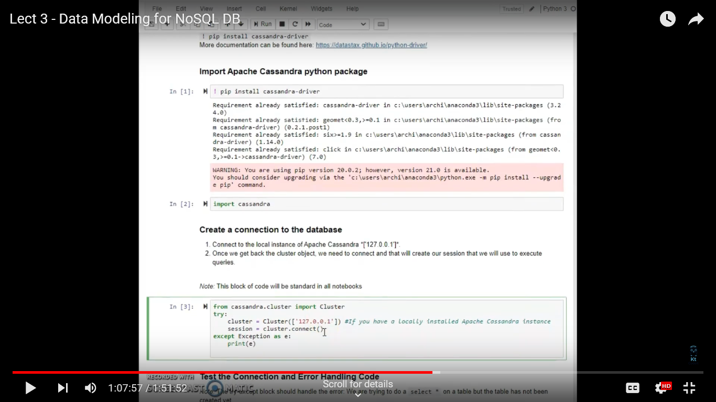

Now, let's create a connection to the database in cell3. This connects to our local instance of Apache Cassandra. Again, the connection will reach out to the database and ensure we have the correct privileges to connect.

Once we get that, the cluster object back, we need to connect and then we'll create a session so that we can execute the queries. Again, this block of code will be pretty standard in all of our notebooks. So, we were able to connect, so let's test our connection.

In cell4, We're trying to do a select star in a table that we have not yet created. So, we should expect to see a nicely handled error. So as you can see in the output, We see an error, but that's what we expected. So, we have not specified our key space yet, and our key space is like our database. So, we need to create a keyspace before we can do a select star.

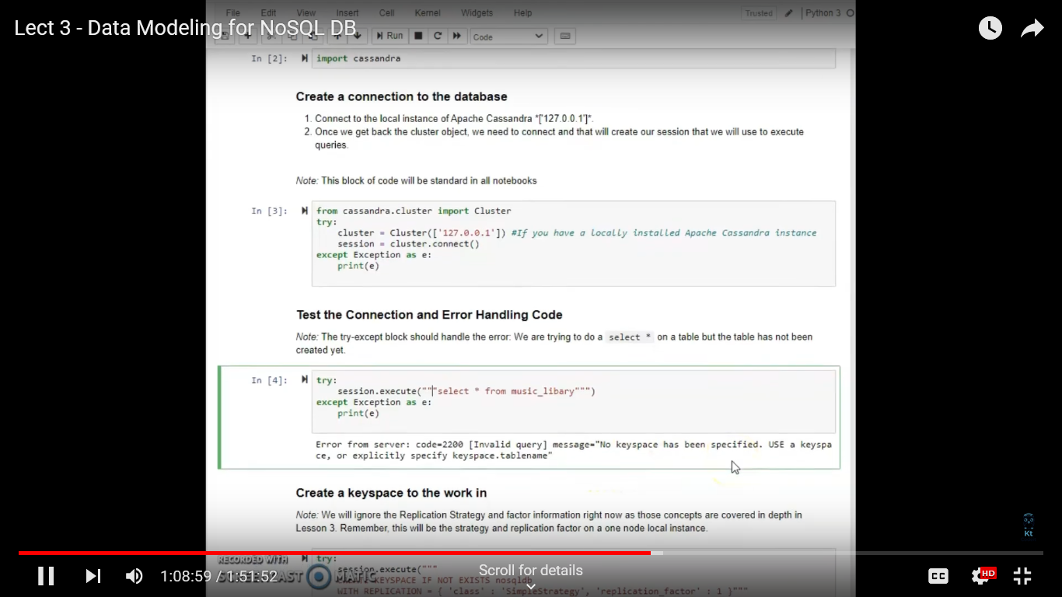

In cell5, let's create that key space to do our work. So, in this case, just ignore the replication strategy and the replication factor for now. We'll talk about that at a later time. But just know that for a one node local instance, this will always be your strategy and your replication factor. Just a little bit about a replication factor, it simply means how many times your data is copied.

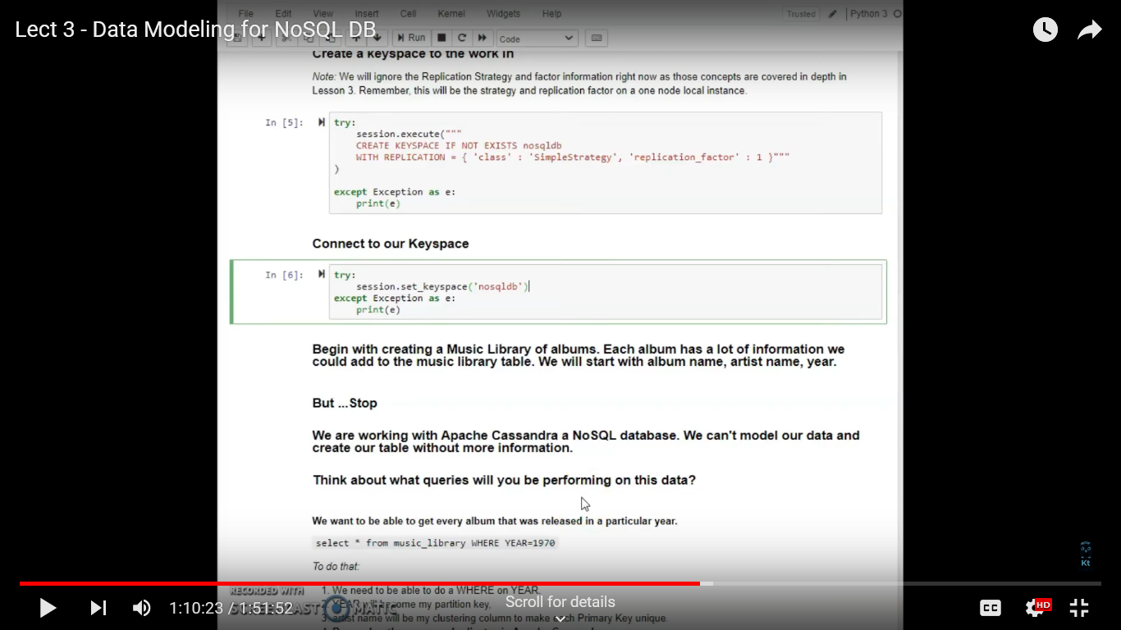

Since we're on a one node, we don't want to copy it across multiple nodes because we don't have them, we only have one. So, we're going to create our key space if it doesn't exist. In this case, we're going to create a key space called nosqldb. Then, with our replication, we're going to use a simple strategy and a factor of one. Then, let's connect to our key space in cell6.

As you can see, We're just able to set the key space here, we don't need to make a new connection. It's very convenient. All right, so let's start creating our tables.

Let's imagine we'd like to start creating a music library of albums. Each album has a lot of information we could use but we're just going to start with the

* album name,
* artist name, and
* year.

But, stop, wait. We are working with Apache Cassandra, a NoSQL database. We can't model our data and create our table without more information. What queries will I be performing on this data? In this case, I'd like to be able to get every album that was released in a particular year. View this query here. Select star from music library where year equals 1970. Because of this, I need to be able to do a where on year. Year will become my partition key, and the artist name will be my clustering column to make each primary key unique. Remember, there are no duplicates in Apache Cassandra. If I don't have a unique key, it will just get overwritten.

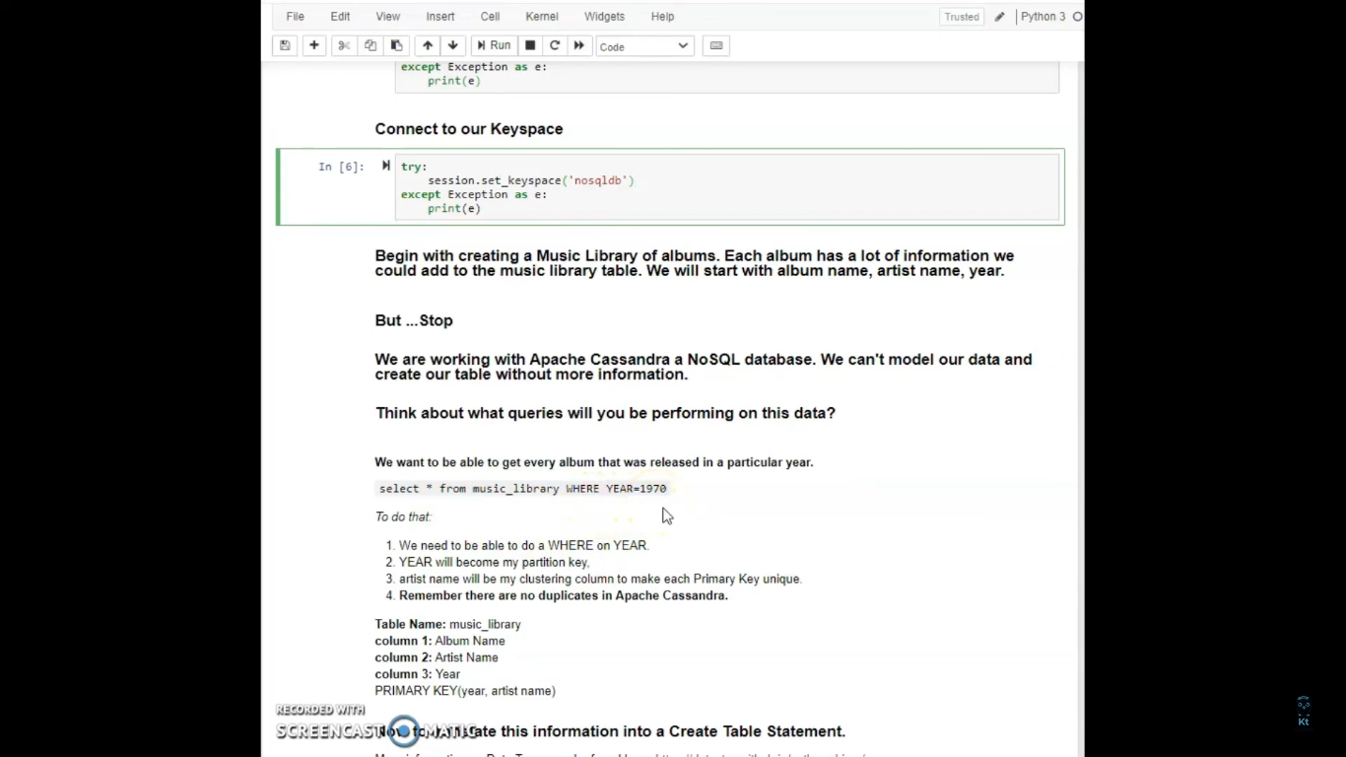

So, in this case, my table name will be music library. My column will be album name, artist name, year, and then here's the key, my primary key.

I'm going to partition by year and then include my artist name to make it unique, because we're imagining that an artist doesn't create more than one album in one year. It's just an assumption that we're making for this demo and actually may be incorrect. But just for the sake of this notebook, that's what we're assuming. Now coming to cell7,

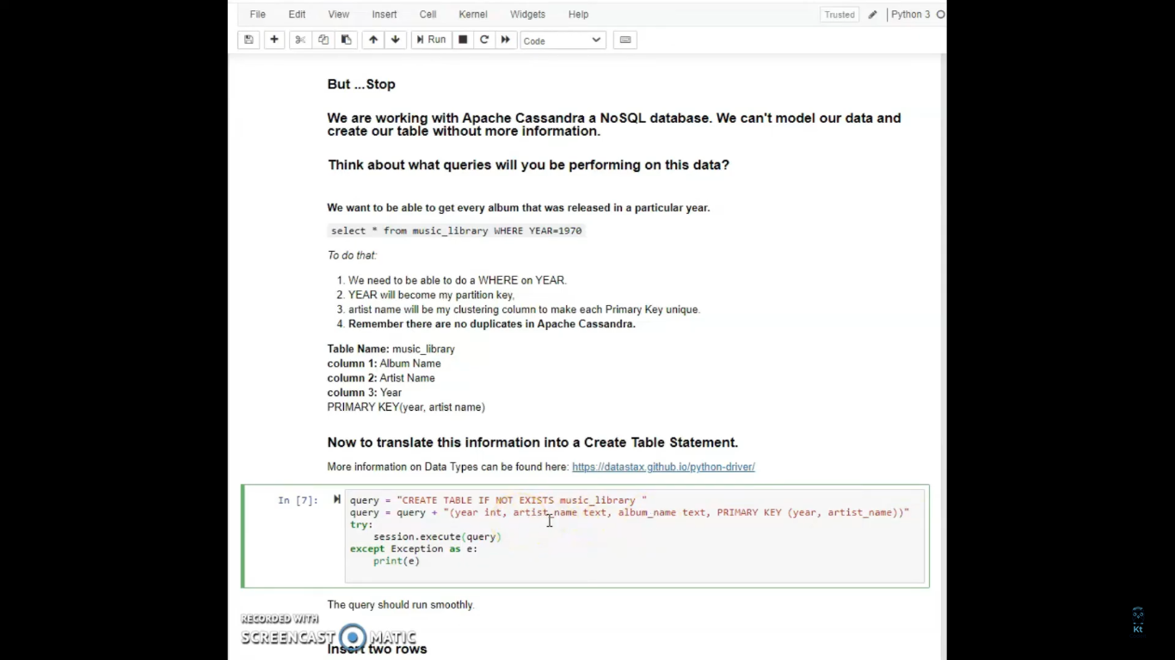

let's translate this information into a create table statement. So, we're going to create table if it does not exist, music library. Then, from there, we're going to have the year which will represent as an int, our artist name which we'll represent as text, our album name as text, and here, we're setting our primary key. Primary key, year, and artist name, and that needs to be in parenthesis. So, if no errors were found, but let's check to make sure our table was created.

You can do a select count star which should return a zero as we have not inserted any rows. Now, depending on the version of Apache Cassandra you have installed, this command may actually throw an error or it may show the answer of zero.

This is to be expected. Because, these types of queries aren't normally performed on large datasets. But on a large dataset, maybe a table spread across thousands of nodes, you do not want to do a select count star or a select star. So, again, coming to cell8, let's insert our two rows.

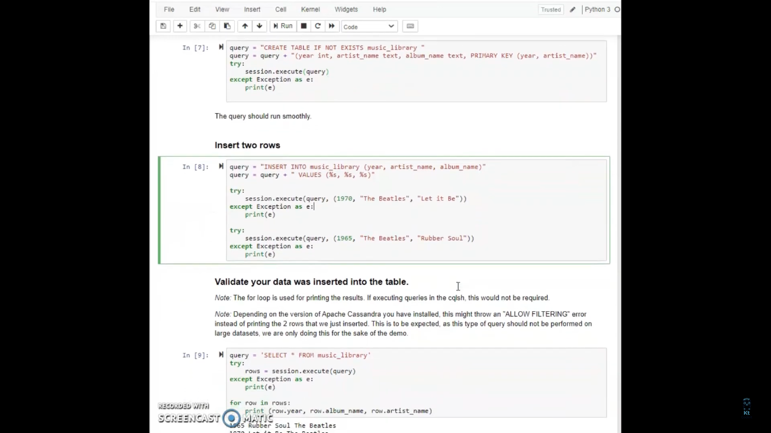

So, we're going to insert into music library, and in this case, we just set up one query variable so that we can just utilize that again and again. But as you can see, right, we have our insert, we have our columns listed here, and then our values with a percent s. Then, we're going to fill those in with using the session execute, and then our query, and then our information that we're going to provide to that query statement to be executed.

So, we have the year, the artist name, and the album name. All right coming to cell9, let's validate that our data was inserted into the table.

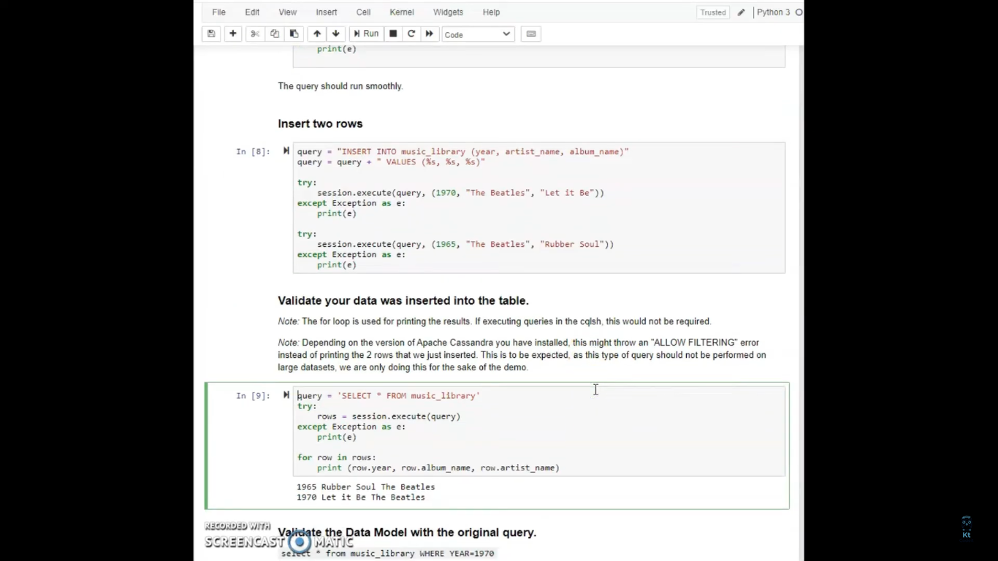

So, in this case, just for the sake of this notebook, like I said before, we're going to do a select star from the table, but on a real production system, we would never do this query. Okay, and we got back our answers so we were successfully able to query that table and we load at that table.

Again, because Apache Cassandra does not allow for duplicates, I can run that insert statement as many times as I want. We'll never get more than two rows. So in cell10, let's validate our data model with the original query.

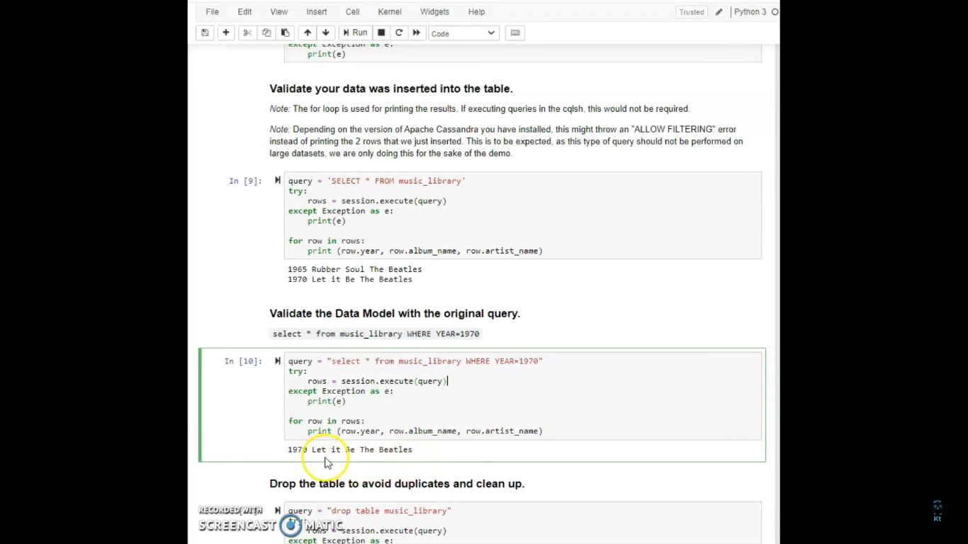

Select star from music library where year equals 1970. So, here's my query here. I'm going to execute it with a session execute. Then, I'm going to print my rows.

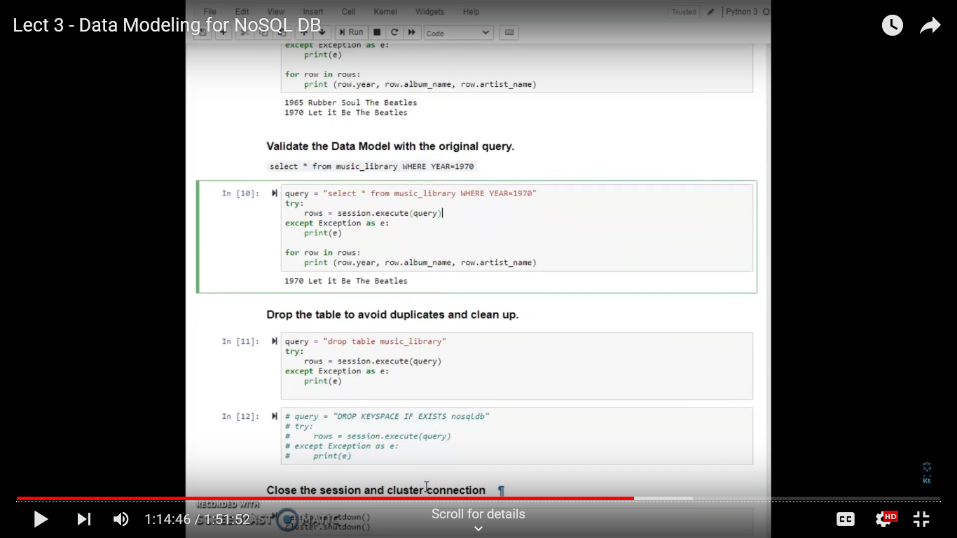

Wonderful, I got back my information that I needed. So, I have 1970, Let It Be, and The Beatles. Now just for the sake of this notebook in cell11, I will drop this table, You can also drop the keyspace by uncommenting the code in cell12.

Then, we're finally going to close out this session and the cluster connection in cell13. So that ends our first notebook. ------

**second notebook**

So then lets move on to our second notebook, where we are trying to do a similar king of thing like before. And I’ll be repeating a few things so that it becomes a lot clearer and gives you additional practice. So in cell1 of course we're going to "import" our Python driver ie "import" Cassandra.

Then in cell2, we're going to create that connection to the database, and then we're going to test out our connection, just to make sure that even though we didn't get an error thrown back, let's just double-check that we're able to connect to the database.

Now coming to cell3, We got an error, which is what we were expecting. This is because No keyspace has been defined. The error says “Use the keyspace or explicitly say a keyspace.table name”. Okay, makes sense.

So let's create our keyspace so that we can do our work from it. Ignore the replication strategy and factor information for now. These will be discussed later. Just know that well one node local instance, this will be your strategy and replication factor.

So in cell4, we're going to create a keyspace if it does not exist. And then in cell5, we're going to connect to our keyspace. All right,

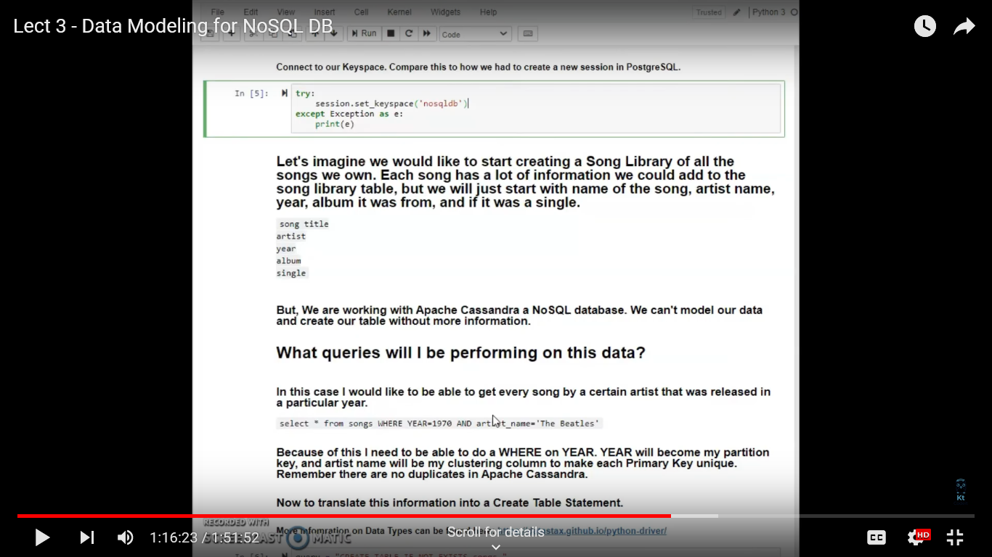

let's get to data modeling. Let's imagine we'd like to start creating a song library of all the songs we own. Each song has a lot of information we could add to the song library table, but we'll just start with the name of the song, artist's name, year, album it was from, and if it was a single, if it wasn't part of an album.

So, song title, artist, year, album and then single. But stop. We're working with Apache Cassandra, a NoSQL database. We can't model our data and create our table without more information. What queries will I be performing on this data? If you remember to ask this question whenever you're doing data modeling in Apache Cassandra, you're in a good spot. In this case, I'd like to be able to get every song by certain artists that was released in a particular year.

Select 'start' from songs where year equals 1970, and artist name equals The Beatles. Because of this, I need to be able to do aware on year. Year will become our partition key, and artist name we might clustering column to make each primary key unique. Remember, there are no duplicates in Apache Cassandra. Now coming to cell6, lets translate this to a create table statement.

Create table if it does not exist called songs. We're going to have a

year of an Int.

Song title is text,

artist's name is text,

album name text

and then we're going to have whether it was a single or not and we're going to represent that with a Boolean. From there we're going to do our primary key as year and artist's name. Let's create that table.

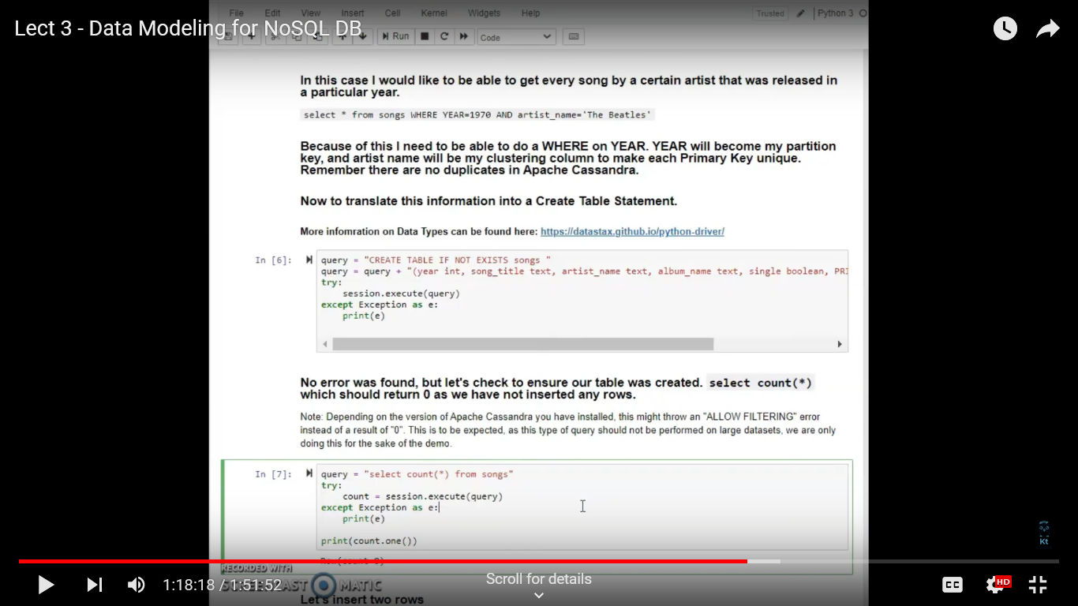

Great. No error was found. But let's check to ensure our table was created. In cell7, Let's do a quick select count star, which should return zero as we have not answered any rows.

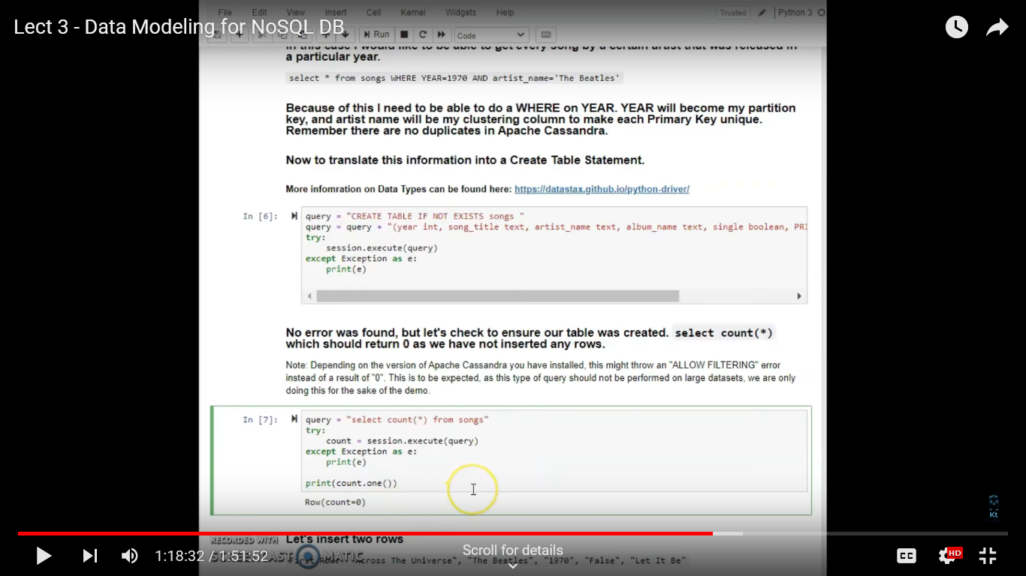

Depending on your version of Apache Cassandra you haven't solved, this might throw and allow filtering error instead of the result of zero. This is to be expected as this type of query should not be performed on large data sets. We're only doing this for the sake of this example.

*So, Select count star from songs.*

So we have created this table but not inserted rows and that's why you're seeing zero.

Let's come to cell8, and insert two rows, In the first row we have across the universe, The Beatles, 1970, false and let it be. And the second row, The Beatles, Think for yourself, false, 1965 and Rubber Soul. So we're going to insert those. Again, note the query here.

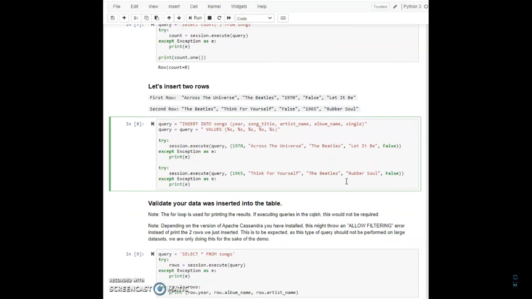

Note the insert statement with the values and then we're inserting the values. so thats done. Now coming to cell9, lets Validate if our data was inserted into the table. The for loop is used for printing the results. If executing this query in CQLSH, which is a shell program that you can use to run a CQL queries,this will not be required.

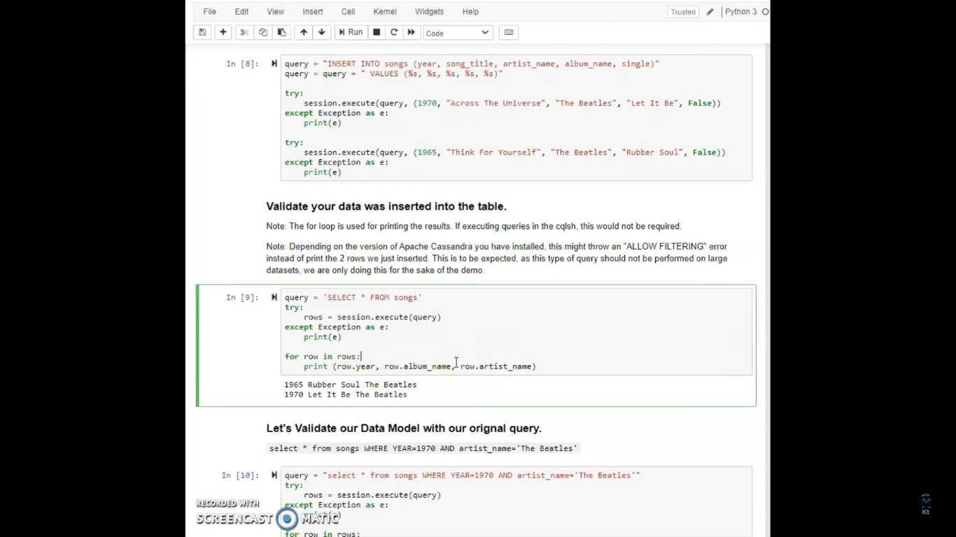

Depending on the version of Apache Cassandra you have installed, this again might throw and allow filtering error instead of putting the two rows we just inserted. This is to be expected as this type of query should not be performed on large data sets. We're only doing this for the sake of this demo. Awesome, we got back our two rows. Now coming to cell10, Let's validate our data model with our original query. Select star from songs *where year equals 1970 and artist name equals The Beatles*. Wonderful, we got back our row. Great. Success.

Finally, let's close out our session and our cluster connection in cell11. And we're done with the exercise.

**Notebook:** de-normalization

------- Now lets see notebook 3, here we are going to solve 3 queries and for each query we are going to have one table. We will talk about the importance of de-normalization and the one table per one query and how it is a practical, good approach with Apache Cassandra. So as usual in cell1, we're going to be utilizing Python driver and we're going to import our Python package called Cassandra.

Now, in cell2, let's create a connection to the database.

Moving on to cell3, So I'm just going to kind of go through this here, again, creating a key space if we don't have it. Now, this is all should be now familiar to you. It's just the basics of setting up, getting ready, getting our session and then executing the query. So let's imagine we'd like to start creating a music library of albums.

We want to ask 3 questions of our data.

**Number One, give every album in my music library that was released in a given year.** So, for any given year, I want to be able to find that. So here's an example of that query *select star from music library, where year equals 1970*. And to be clear the year can be any year. It doesn't just have to be 1970, any given year.

**Number two, give me every album in my music library that was created by a given artist**. So in this *select star from artists library where artist name equals*, and in this case, it could be any artists that we have in our music library that we're looking for. And it's the Beatles, because I want to do two different queries.

**Number three, give all the information from the music library about a given album.** So for this case, *select * from album library where album name is say for eg close to you*. So, I'm going to need three different tables that partition the data differently.

My music library table will need to be by year that's because my partition, that will become my partition key. The artist's name will be my clustering column to make each primary key unique. Now, For My artist library table, it will need to be partitioned by artist's name and this will be my, be my partition key and year will be my clustering column to make each primary key unique.

Lastly, for my album library, the partition key would be album name and clustering column would be artist name.

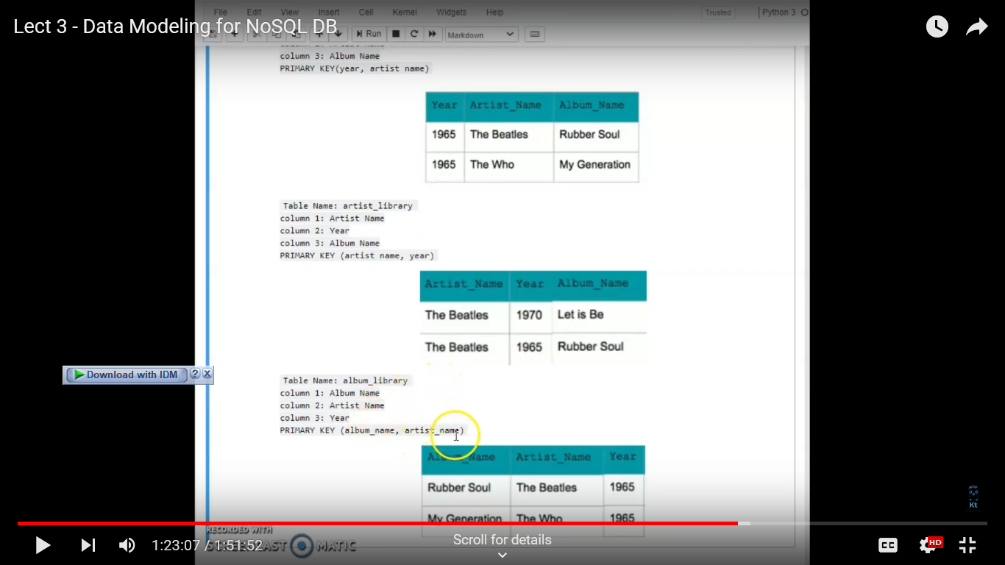

So don’t worry if it’s a bit confusing, just follow along the eg we are going to discuss the theory behind this soon. So again coming to cell5, let's just create the 3 tables as we said earlier.

Now coming to cell6, lets insert some data. This is all pretty straightforward. So I'm not going to go through the insert statements, but we're just inserting data into our 3 tables. So it might have felt as we were doing those inserts that we are duplicating data and you saw a lot of the same data put into different tables.

Lets see an example here, in the first query, we're going to insert 1970, the Beatles and let it be, and then you can see here with query two, we're going to have again, the Beatles, 1970, and let it be. So again, it's duplicate data, so that might've felt a bit odd and you might be thinking If I had just normalize these tables, I wouldn't have extra copies of the data. Wouldnt that be great? Well, that is true. But, Remember, there's no joins in Apache Cassandra. So for the benefits of high availability and scalability, you must de-normalize your tables. So that’s why we purposely inserted duplicate data. So let's coming to cell7 and validate our data model. Let's do that select star from music library, where year=1970. Awesome. Back to the results. We get, 1970, the Beatles and Let it be. The second row gives us 1970, the carpenters, and close to you. Now in cell8, Let's validate our data model for our artist library. Again, let's start from artist name equals the Beatles. Awesome. We've got two results. Just what we wanted. The first row gives us The Beatles, 1965, and rubber soul and in the second row we have the Beatles, 1970 and Let it be. Finally in cell9, Let's validate our data model for our album library. Again, let's start from album name equalsclose to you. Awesome. We've got one result. We get The carpenters, 1970, and close to you.

Now just for the sake of this demonstration, I'm going to drop my tables in cell10 and we're going to shut it down.

**primary key**

So, the primary key is how each row can be uniquely identified and how the data is distributed across the nodes or servers in our system. The first element of the primary key is the partition key which will determined the distribution.

The primary key is made up of either just the partition key or with the addition of clustering columns. Again, the primary key is made up of either just the partition key or with the addition of clustering columns. The partition key will determine the distribution of data across the system.



The partition keys row value will be hashed, turned into a number and stored on the node in the system that holds that range of values. Alright. So, here's an example of a primary key using a simple primary key which is also our partition key. So, I'm going to create table music library.

Again, year int is going to be int,

artist name is text and

album name text and

then our primary key will be then by year.

So again, that means our data will be distributed across our system by the year. So, our primary key is also our partition key. So, some key points about primary keys, they must be unique.

A primary key must be unique to each row. There are no duplicates in Apache Cassandra. Think about your primary key, is it going to end up resolving to a single? Row. If you make your primary key first name, only one Amanda will be allowed in your database, but this is a very common name and there will be more than one.

Data will be overwritten if a new value comes in with the same primary key. An error will not be thrown and the original data will be overwritten. Hashing of this value results in placement on particular nodes in the system.

The value will be hashed to a numeric value and the value will determine whether data will live on the system. Either node one, node two or node 7,000. Data distributed by this partition key.

The data will be distributed across the system by this key. You want to pick a key that will evenly distribute the data as best you can. For example, if you've distributed a customer table by state, you're likely to see an uneven distribution because more people live in California than Vermont. Simple or composite. The simple primary key is just one column that is also the partition key.

A composite primary key is made up of more than one column and will assist in creating a unique value and will help you in getting your retrieval queries. They have one or more clustering columns. We'll talk more about clustering columns in the next section. Again, here's our composite key. So, now we're seeing that same type of query that we had before on music library of the create table and in this case, we have primary key and we have a composite key. We're going to distribute by year with a combination of artist name. So, both of these are the partition key, these values will be hashed together. You'll get one value back and then that data will be stored on a particular node. All of this together is the primary key. Here are two questions 1. True or False:

Apache Cassandra supports duplicate rows.

SOLUTION:False

2. Which is better: Simple or Composite Primary Keys?

* It depends on the data you have and the queries you will do Simple
* Simple is always better
* Composite
* Neither, it is better to use a Relational Database

SOLUTION:It depends on the data you have and the queries you will do All

right. So let's go in our notebook which is going to focus on utilizing and using our primary key. so lets get the usual stuff out of the way, We're going to import our library, we're going to connect to the database, and we're going to create our key space if it doesn't already exist, and we'll connect to that key space in the four cells.

So Let's Imagine we'd like to start creating a new music library of albums. We want to ask one question of our data: Give me every album in my music library that was released in a given year. Select star from music_library, where year equals 1970.

Here's the collection of our data.

Here's the year,

we have information about the city,

we have artist's name and

album name.

So let's look at our data. How should we model this data? Let's think about it. What should be our primary key? What should be our partition key? Since our data is looking for the year, let's start with that. Is partitioning our data by year a good idea? In this case, our data is very small. But if we had a large data set of albums partitioned by year, it may be a fine choice.

You would need to validate from your data set, look at your own data and then model it to that. But, essentially, we want to spread the data equally across our nodes. So, in this case, we're going to create a table called music library with a column year, artist's name, album name, and city, and our primary key is going to be on year.

So let's create our table in cell5. Let's insert our data into the table in cell6. So we're going to insert all that data we saw up above in this chart. So, let's insert into our table, and let's validate our data model, Did it work? In this case, we can use the year 1970 or we can use any year. So I'm showcasing this here. So in cell7, we're going to look for albums that were released in 1965. We should expect to see two rows. So let's go back here to our chart. As you can see, there is The Beatles and Rubber Soul, 1965. We also have The Who, My Generation also 1965. So I should expect to see those two back when I run this query. That didn't work out. Why is that? Because we did not create a unique primary key. That's why. So, I had written in that 1965 for The Beatles, and then it got overwritten by The Who, My Generation. So let's try again. Let's focus on making the primary key unique. Look at our data set. Do we have anything that is unique for each row? We have a couple of options. In this case, we have city and album name, but that will not give us the query we need, which we are looking for the album in a particular year. Let's make a composite key of the year and the album name. That is assuming that the album name is unique to the year it was released. This is not a bad bet. But, remember, this is just a demonstration. You will need to fully understand your own data set. No betting on your own data. So in cell8, we're going to create the table, and again we're going to use a composite key here with year and album name. We're going to create that query, and again we're going to do our insert in cell9. So, let's validate our data model in cell10. Did it work? If we look for albums from 1965, now we should see two rows. Awesome, success. It worked. We created a unique primary key that evenly distributed our data. Now lets finally drop the tables in cell11, and we're going to close our connection in cell12. I have also included a practice notebook named 5. Focus on Primary Key Practice for you all to practice on your own. Now let's move on to clustering columns. The PRIMARY KEY is made up of either just the PARTITION KEY or with the addition of CLUSTERING COLUMNS.

The CLUSTERING COLUMNS will determine the sort order within a Partition. The clustering columns will sort the data in sorted ascending order. More than one clustering column can be added or like we talked about before, or none. So, in this case, we have a Composite key with it we're partitioning by year, and then from there we have a clustering column on artist's name, and album name. So, you can see here in this example if I did a select star from that music library, you can see that I have my year, and then my artist's name which is then in alphabetical order in ascending order; E comes before T, and B comes before M. Then after that, it's going to sort by album name. So, here you can see again so, Elvis so Blue Hawaii, and then we're going to sort the Beatles. Here we're going to have Rubber Soul, and then here I just wanted to make sure it was something that came after Rubber Soul, so I made it not really an album it's called, 'Showing the order'. So, here it's going to be in ascending order as you can see. Then here we'll have the item for the Monkeys. From there, the clustering column will sort in sorted order, and how they were added to the primary key. So, for example, in this example that I just showed, they will be distributed by the key, then sorted in ascending order by first the artist's name, and then the album name. So, the primary key is made up of a partition key which in this case is year, and a clustering column which is the artist's name. Remember this is just an example. It might not be unique enough of a value. Let's say that the artist created two albums in one year. Then this data model would not hold up. But just for the sake of this example, we're going to assume that it's unique. So, here we're going to use our partition key here which is year, and our clustering column artist's name. So, you may think How many clustering columns can we add? You can use as many clustering columns as you would like. You cannot use the clustering columns out of order in the SELECT statement. You may choose to omit using a clustering column in your SELECT statement. That's OK. Just remember to use them in order when you are using the SELECT statement. Now lets see two questions. 1. The PRIMARY KEY is made up of… The composite key, the primary key, and the clustering key The composite key, the partition key, and the clustering columns The partition key and the clustering columns SOLUTION: The partition key and the clustering columns 2. True or False: A Clustering Column is required in the Primary Key SOLUTION: False All right. So in this notebook, its time to focus on clustering columns. All right so lets execute the first 4 cells and get the usuals out of the way. Let's imagine we'd like to start creating a new music library of albums. We want to ask one question of our data, give me every album in my music library that was released by an artist with album name in ascending order and city in ascending order. So, my query might look something like this, select star from music library or artist name equals the Beatles. So, then here's my collection of data that I have. So, how should we model this data? What should be our primary key and our partition key? Since our data is looking for the artist name, let's start with that. From there, we'll need to add other elements to make sure that the key is unique. Again, because we need to start with artist name, we have duplicates, for example, for the Beatles, we have 2 rows that have the Beatles as their artist's name. So that's not going to be unique enough to be our soul partition key. So we're going to need to add other elements to make sure that the key is unique. We also need to add the city, and the album name as clustering columns to sort the data. That shouldn't be enough to make our row key unique. So, we're going to have music library, column year, artist name, album name, and city. So again, we're going to start with our partition key, our partition key always goes first, artist name, from there we're going to have album name, and city. Now coming to cell5, Let's create the table if it does not exist. Again, album name and city are our clustering columns. Great, in cell6, let's insert our data into the table. Again this looks like all the other inserts that we've done before. Now coming to cell7, Let's validate our data model. Did it work? If we look for albums from the Beatles, we should expect to see three rows. Again here's our query, select star from music library were artist's name equals the Beatles, and we're going to run that query and print the result. Awesome. The Beatles, Beatles For Sale London 1964, The Beatles Let it Be Liverpool, The Beatles Rubber Soul and Oxford. So as you can see, we have our partition key, and then our clustering columns are in order. Beatles, let, and rubber that's in ascending order. Success, it worked. We created a unique primary key that evenly distributed our data, with clustering columns that sorted our data, and for the sake of the demonstration at last I will drop the table, and finally am going to close my session. Now I have include another notebook named 7. Focus on Clustering Column Practice and you can practice another example there on your own So, now we're going to be talking about the WHERE clause. Data modeling and Apache Cassandra is query focused. The focus needs to be on the WHERE clause. The partition key must be included in your query and any clustering columns that can be used in the order they appear in your primary key. Failure to include a WHERE clause will result in an error. Let's walk through an example with our music library table. Because we have quite a few queries on this screen here. Let's walk through them one by one. So, the first query here, select star for music library where year equals 1965. Will get you back everything in your partition. This is all the data you have stored on one node. Be careful with this type of query. Remember, no sequel is made for big data. This could be getting back terabytes of data or even more. Always be aware of the potential performance issues that might result from pulling back large amount of data. Our second query here, select star from music library where year equals 1965 and the artist's name equals The Beatles. See here that we're utilizing our clustering column to fetch more specific data. We must use the clustering columns in the order that they were provided in the primary key. I cannot do a select star from music library where year equals 1965 and then album name Let It Be. That will result in an error because we partitioned by year and our clustering column was artist's name, not album name. Number three our third query, select star from music library where year equals 1965 and artist's name equals The Beatles and album name equals Rubber Soul. In this case, we will be getting back one row of information in our table. I have used my partition key and all my clustering columns to fetch the data. Note that The WHERE clause must be included in our executed query. It is recommended that one partition be queried at a time for performance implications. It is possible to do a select star from table without the WHERE clause if you add a configuration called ALLOW FILTERING to your query. This is risky but available and absolutely necessary. They should be done with extreme caution. I actually will not even provide the syntax for you but it is available to you. No sequel is all about big data and high-performance. Keep those factors in mind when performing queries. Thousands of nodes systems exist of Apache Cassandra and select star on that system will be trying to pull all the data to the client from thousands of nodes. This is called a full table scan. Best case, would that it'd be extremely slow. Worst case, it could bring down your system. Adding the WHERE clause we'll make sure this doesn't happen and you're serving the requests with low latency and high performance. So you might think, Why do we need to use a WHERE statement since we are not concerned about analytics? So, The WHERE statement is allowing us to do the fast reads. With Apache Cassandra, we are talking about big data -- think terabytes of data -- so we are making it fast for read purposes. Data is spread across all the nodes. By using the WHERE statement, we know which node to go to, from which node to get that data and serve it back. For example, imagine we have 10 years of data on 10 nodes or servers. So 1 year's data is on a separate node. By using the WHERE year = 1 statement we know which node to visit fast to pull the data from. Lets look at a question, Can you do SELECT * FROM myTable in Apache Cassandra? Yes No It is highly discouraged as performance will be slow (or may just fail) but it is possible with a configuration setting Yes, and no one should worry about it SOLUTION: It is highly discouraged as performance will be slow (or may just fail) but it is possible with a configuration setting All right. Lets move on to the last notebook and Let's focus more on this WHERE clause. We're going to go and open our Jupyter notebook. We're going to import our library, connect to our cluster, create our key space if it does not exists, connect to our key space, and there we go. Let's imagine we'd like to start creating a new music library of albums. We want to ask four questions of our data. Give me every album in my music library that was released in a given year. So that will be Select star from music library where year equals anything. Give me the album that is in my music library that was released in a given year by The Beatles. Select star from music library where year equals a particular year that you choose and artist name. In this case, we're choosing The Beatles. Third, Give me all the albums released in a given year, in a given location. Select star for music library where year equals 1970 and location equals Liverpool. Lastly, Give me a city that the album Let It Be was recorded. Select city from music library where year equals 1970, and artist name The Beatles, and album name Let It Be. So, Here's a collection of our data, similar to that data that we've seen before. How should we model this data? Again, every time I start these demonstrationss, that's what I start you with, because that's what we have to be thinking about. How should I model this data knowing my queries in advance? What should be our primary key and our partition key? Since our data is looking for year, let's start with that. From there, we'll add clustering columns on artist name and album name. So in cell5, let's create our music library, year, artist name, album name, and city. We're going to partition by year. We're going to use a clustering column for artist name and album name. Let's insert our data into the table in cell6. Again, very similar to what you've seen before. Now coming to cell7, Let's validate our data model with our four queries. Select star from music library where year equals 1970. So, I get 1970, The Beatles, and 1970, The Carpenters. Success, it worked. Let's try our second query in cell8. Select star from music library where year equals 1970 and the artist name equals The Beatles. Awesome. I got back my result. It worked. Let's try the third query in cell9. Select star from music library where year equals 1970 and location equals Liverpool. We get an error. This error, means that you can not try to access a column or clustering columns if you have not used the other defined clustering columns. Let's go back to where we created our table. So, here, we have our partition key of year, our clustering column of artist name, and our clustering column of album name. You have to utilize them to do a query. You have to use these in order. Also, if we wanted to use and city, we have to use it after we've used all of these columns. So, year, artist name, album name, and city. We can't just use any column. We have to use all the clustering columns in order. That's why we got a failure and it was expected. So this is why Query 3 is incorrect. So coming to cell10, let's see if we can do this in a different way. Select city from music library where year equals 1970, and artist name equals The Beatles, and album name Let It Be. So, again, we're utilizing all of our clustering columns in the query, and we get back Liverpool. So, at last I will drop the tables. Then, we'll close our connection. Awesome. All right. So we're ready to wrap up. We've gone through all our notebooks and demonstrations. So what did we learn in this lecture? We learned about the basics of distributed database design and why the affects of that will affect our data modeling decisions. NoSQL is already optimized for rights. So we must model our data to allow reads to be fast. We must have our queries and model the tables to our queries. Always data model with queries in mind. Importance of denormalization: We learned why we must denormalize to allow for fast reads. We learned about Apache Cassandra and how it is a very popular NoSQL database. Then it's also used in a number of very high profile companies. We learned about the primary key, partition key, and clustering columns. We learned about the primary key and how that is made up of partition key, which distributes the data, and the clustering column, which orders the data. We learned about the where clause as we must think about our queries, and that we have limitations on select star. So this ends our lecture 3.

What is Postgresql

So in this lecture we are going to learn about Data Modeling with Relational Databases and focus on data modeling with PostgreSQL.

Let's kick things off with a brief discussion about what PostgreSQL is and why it might be a fantastic choice for meeting your data platform requirements.

PostgreSQL, or simply "Postgres," is a robust relational database management system, or RDBMS. According to the folks at db-engines.com, it ranks as the fourth most popular database platform in the world, behind industry powerhouses Oracle, MySQL, and Microsoft's SQL Server. But unlike those three platforms,

Postgres has seen a steady increase in popularity over the last six years. This trend in popularity could be attributed to a number of different factors.

First, PostgreSQL is an open-source project, which makes it free for any organization of any size to pick up and apply to their needs. Compare that with some of the other popular platforms that can cost thousands or hundreds of thousands of dollars to deploy across the organization. You'll see why Postgres is a good choice from a simple financial perspective.

Second, Postgres has been in active development for over 30 years. It has gained reputation for being a reliable, robust, and secure data platform. This is in large part due to its nature as an open-source project, where people from all over the world collaborate to examine source code, help identify and fix bugs, and develop new features.

Finally, as more very large businesses push Postgres to its limits, it gives smaller users more confidence in the platform's capabilities, which makes transitioning from a paid commercial database platform even more justifiable. After all, if organizations the size of Reddit, Apple, and Yahoo, trust Postgres to meet their needs, then it's definitely up to the task of handling anything that I could throw at it.

Now I mentioned that Postgres was a relational database management system, so let's unpack what exactly that means.

An RDBMS creates a protective wrapper around your data. It gives your data a place to live, controls how it gets entered, and under what circumstances it could be modified or deleted. The RDBMS also secures your data and ensures that only people in applications that have expressed permission to view and change the data, have the ability to do so, and keeps everyone else locked out.

Finally, an RDBMS manages the performance of the system, which helps you enter data and retrieve information in the most efficient way as possible.

To do all of this, Postgres uses a server/client model. The Postgres server handles the storage, security, and maintenance of your data by storing it in a container called the database. Each Postgres server can hold many different databases. A client application is then connected to the server so that end users can input data, modify that data, and then retrieve that data back out again. The beauty of this arrangement is that the server can exist on a centralized computer that provides a single point of contact for all of the different users in an organization. Then each user uses their own desktop computer, running their own client application, to access that shared resource pool. In this way, everyone across the organization is getting the same information, updating the same data tables, and viewing the same detailed reports.

In order to perform all of the tasks that a PostgreSQL server needs to do in order to manage your data, you'll need to become familiar with the SQL programming language. So, SQL stands for Structured Query Language, and it's a common language used by data science professionals in practically every database application in use today. This makes the ability to read and write SQL commands a very transferrable skill that's highly sought-after in the workforce. Unlike many traditional programming languages, SQL uses human-readable syntax that's straightforward and flexible, so don't let the idea of learning a programming language scare you off.

I'll introduce you to the basics in this course, and you'll be writing your own SQL commands in no time. So that's the basics of what PostgreSQL does, and how it can be used to help protect and store your valuable data.

Now I have provided you the with the information on how to install postgresql. Hopefully you all don’t face any issues in that.

Okay, so once you have got your postgresql installed, let's get started with our demos. So, we're going to be focusing on using Jupyter notebooks and using Python Wrappers to execute our queries, and all these queries you're able to do them just in either PostgreSQL shell, but we're just going to focus on utilizing a Python Wrapper for these. But before we do anything in our jupyter notebooks, lets go to pgadmin, start our postgres server, and create a dummy database.

So as you can see we are in the pgadmin interface and this browser will automatically open up once you start pgadmin. So we will right click on databases and create a new database studentdb. Now once we have created this database we will get back to our notebook.

So let the pgadmin run in the background and do not close it. So, we are back in our notebook and, actually, I'm just going to talk about something that you may come accross when you're working with Postgres, and it's about AutoCommits.

So, in this case, we're going to use this Python package here. We're going to use this as our wrapper, and this Python package wraps around Postgresql.

So in cell2, let's create a connection to our database. This connects, in my case, to a local instance of Postgres. From there we're going to use the database/schema, which in this case is the student db, and then our username and password.

This connection will connect the database and ensure that we have the correct privileges to connect to the database.

Next in cell3, let's use the connection to get a cursor and we'll use that to execute the query. We have our cursor now.

So in cell4, let's try to actually run a query.

"Select star from test" No, we have an error. It says, "Relation udtest doesn't exist." Okay. That's no problem. So, we get an error but we were expecting that. So, let's go fix this error by creating a table.

In cell5, I'm going to create table test on columns. This is just an example. So, I have three columns and they're all ints. I'm going to run this. I've gotten another error. "Current transaction is aborted. Commands ignored until end of transaction block." That's not what I was expecting at all. So, when you're using Postgres, what we need to make sure that we understand is that, again, because we're working with an acid database, that we need to make sure that we commit our transactions. So, when I had that error in my query, I did not commit my transaction and so I got an error. So, as we have not committed the transaction, we had an error in our transaction block. At this point, we're blocked until we restart the connection or we could have committed the transaction, either one. So, let's just get our connection again in cell6. Okay. So, we're going to connect to our database and then we're going to get our cursor. So, in these exercises, the point of this demo is instead of worrying about committing after each transaction or getting that strange error that we just got, let's just set autocommit to "True." Now coming to cell7. So, this says that after each call during the session, commit that one action and do not hold open a transaction for any other actions. So, one action will equal one transaction. So, for this demo, we're going to set autocommit in the session to "True." And we won't have to call conn.commit for each commi. So in cell8, let's create table test with our three columns, and executed successfully. Wonderful. That's exactly what we wanted. When we execute this code again with autocommit set to true, we didn't face any issues with the transaction blocks, and we did not need to restart our connection. So in cell9, let's just do a "select star from test ", and since we don't have anything there, we didn't get anything back. Let's do a "select count star" in cell10, and we see that we have zero rows in the table because we didn't add anything. Then, let's just drop the table in cell11. So, this was just a demo to make sure that you understand why we're setting autocommit at each one of our demos. And finally in cell12 we will close our cursor and the connection to postgres. So, from here, we move on to the next notebook. This is all about creating a table in Postgres. In this notebook, we're going to walk through the basis of creating a table in Postgres, inserting rows of data and doing a simple SQL query to validate that information. So in cell1, We're going to import the library. Again, if an error pops up, make sure that you read it thoroughly but it may be something you can ignore. All right. Let's create a connection to the database in cell2. This connects to our local instance in our case of Postgres. From there we'll use the database stduentdb and the schema. This connection will reach out to the database and ensure that we have the correct privileges to connect to this database. So, I just want to let you know just here as a note, this block of code that you're seeing here is going to be very standard in all our notebooks. We're adding this "try except" block to make sure that errors are caught and understood. This is just good coding techniques and practice. So, you need to have that just to make sure that you're catching any errors, but you really want to focus on what's in the "try" command. The rest is just pretty standard, we'll be using it again and again. So now coming the block of code in cell3, this will help us to make our connection. Next, we're going to use that connection, to get a cursor, so that we can use that cursor to execute the queries. Again in cell4, for this notebook, we're going to use the autocommit=True, and what this will do is for each action we wont have to call conn.commit again and again. The ability to roll back and commit transactions are a feature of relational databases. So in cell5, let's actually create a new database so that we can do our work. Let's create a database called student1. Now, in cell6, Let's close our connection to this default student db database, and reconnect to the student1 database and get a new cursor. As you can see here we're going to close the connection, and then from there, we're going to connect to our new database student1, and then we're gonna get the cursor. So all those are going to happen in the same cell, and we also set our autocommit to true and all of that ran successfully. Okay. So, now that we've done some of that upfront work, let's actually start thinking about creating our table. Now, Let's imagine we're going to start creating a Music Library of albums. Each album has a lot of information we could add to this music library table, but we'll start with just the album name, artist's name, and year. The type of table we want to create and the columns we need seemed to really fall out very naturally. So, let's imagine that our table name is going to be "music_library." We're going to have three columns one called Album Name, Artist Name, and Year. So now we want to translate this into a create table statement. So in cell7, again, in our try/catch block, we're going to create table if not exist. So, if it doesn't already exist, create it. If it does exist, don't create it. We're going to call it "music_library" and we're going to have our three columns, Album Name and that's going to be a varchar like a string, our Artist Name, again a varchar, similar to a string, and Year, we're going to use an int, an integer. So now in cell8, let's go about the process of inserting two rows. So, I really want you to note the syntax here of how we're doing this in this insert statement because you'll be doing this again and again throughout our exercises. So, this is the syntax that you'll use. So, we're going to insert into our music_library, we're going to list our columns, then we're going to use our values, and we're going to use the percent sign and s, and then we're going to add a comma and then we're going to add in each one of the actual values that we're going to enter in. So, in this case, we have a music_library, we add the details. So, we're doing the same here for another album. So, we're going to insert two rows. Now in cell9,Let's validate that your data was actually inserted into the table. So, we're going to do a "while loop" and we're going to use that for printing the results. If you were executing this query in the PostgreSQL shell, you wouldn't really need this while loop. But in this case, we do because we're utilizing the Python library. Also just a note here, So, if you do end up running this insert statement code in cell8, more than once, you're going to actually see duplicates of your data. So, just to let you all know, Postgres, allows for duplicates. So in cell9, we did a "select star from music_library" and we were able to print out our results. So successfully, it got loaded into the table. So in cell10, then we're going to finally close out the connection to our database. So, that is the end of this part. So now lets move on to data modeling with relational databases. Here you will be learning the fundamentals of how to do relational data modeling by focusing on normalization, denormalization, fact tables, dimension tables, and different schema models. Again, I just want to make sure everyone knows that really want to have a strong understanding of normalization and denormalization. Those are the biggest heaviest topics we're going to discuss today. So, really make sure you take the time to make sure you fully understand these topics. So, first, we're going to go through just a little bit of definitions and history before we get into some of the fundamentals of what we're going to talk about. So, let's start with a few definitions to make sure we're all on the same page. A database is a set of related data and the way it is organized. Access to this data is usually provided by a database management system. So, what is a database management system? This consists of computer software that allows users to interact with the database and provides access to all of that data. Because of the close relationship, the term database is often used to refer to both the database and the database management system. So, let's talk about the importance of relational databases. So, a little bit of history here. The concept of relational databases was invented in about 1969 by researchers at IBM. Edgar R. Codd was the lead researcher. He proposed 12 rules of what makes the database management system a true relational system. We won't go over each rule, but I want to focus here on rule one because it's particularly important for this course. Rule one, the information rule. All information in a relational database is represented explicitly at the logical level in exactly one way by values and tables. Rule one, is what we're trying to achieve with data modeling. Remember, this is all abstract concepts of relational modeling and what makes a system a valid relational model. So, why is the relational model important? Number One, Standardization of the data model. It takes work and effort to get your data transformed into the rows and columns format. But once you do this, your data is in standardized and we'll be able to be query with SQL. Number two, flexibility in adding and altering tables. Relational database gives you the flexibility to add tables, alter tables, and add or remove data. Remember, these are the basics of what makes a database also a relational model. Data integrity. Data integrity is the backbone of using relational model. You'll remember from lesson one, we talked about this quite extensively. Strong data typing ensures data that does not fit the model will not be inserted causing corruption. Number four, Standard Query Language. Standard language can be used to access the data with a predefined language. Simplicity. Then finally, intuitive organization. The most important benefit for us to remember, is that data is systematically stored and modeled, and that the modeling process is an intuitive process. If you've created a spreadsheet in Excel, you have created tables and modeled your data. It was so natural, you didn't even think that you were doing data modeling but you really were. More complicated systems require more intense thought and experimentation, but the basics are really the same. Now, A quick note on the difference between Online Analytical Processing or OLAP or OLTP, Online Transaction Processing. Online Analytical Processing or OLAP. Database optimization for these workloads allow for complex analytics and ad hoc queries. These types of databases are optimized for read. Online Transactional Processing, OLTP. Databases optimized for these workloads allow for less complex queries in large volumes. The types of queries for these databases are read, insert, update, and delete. So, let's go through an example so we can understand the difference between the two. OLAP query will tell you how many shoes, last week, were sold in stores in California. You can see that it's already an aggregation that you'd have to do to get that data. You're doing analytics and aggregations on your data. Those are OLAP queries. An OLTP query will tell you the price of the shoes. Imagine just doing a select star on a particular table and getting back a result. OLTP queries will have little aggregations really, if any, while OLAP will heavily focus on aggregations. So here are two questions Question1 - True or False: OLTP queries are read heavy and focus primarily on analytics. True False SOLUTION: False Question 2 - What makes data modeling for relational databases different? The ability to model data in a way that is intuitive You must model for your queries first There is no flexibility or agile nature to this process SOLUTION:The ability to model data in a way that is intuitive So, let's talk about structuring the database. So, the two biggest concepts of data modeling and relational databases are normalization and denormalization. Normalization: to reduce data redundancy and increase data integrity. Reduce data redundancy, right? What is data redundancy stand for? That means, copies of my data. Increase data integrity, what is data integrity mean again? That means that the answer that I get back from the database is the correct answer. Two very important things. Denormalization: this is a process that must be done if you're doing read heavy workloads to increase performance. So, normalization will feel like a natural process. It's going to feel natural. Not as you go through the normal forms. Third normal form starts to feel little unnatural but that's okay. But it should feel like a natural process. You're going to be reducing the number of copies of the data and increasing the likelihood that your data is correct in all locations. That feels very natural, feels like something that we want to do. Denormalization: it will not feel as natural. You're going to have duplicate copies of your data. That may not feel natural to you, right? That may seem like, "Well, if I have all this information in one column, I don't want to have it all in another column in a table, I want to normalize it." But sometimes denormalization must be done for performance reasons, and we're going to talk about that here in a couple of minutes. So, these tables are going to be more focused on the queries that will be run. This is what we were talking about when we were talking about NoSQL databases yesterday in lesson one. Okay. So, let's focus a little bit more on normalization. The process of structuring a relational database in accordance with a series of normal forms in order to reduce data redundancy and increase data integrity. So, this process was actually proposed again by Edgar Codd. He sounds like he must be the father of relational databases. Normalization organizes the columns and tables in a database to ensure that their dependencies are properly enforced by the database integrity constraints. We don't want or need extra copies of our data, that is data redundancy. We want to be able to update our data in one place and have that be the source of truth, that is data integrity. The more copies of the data is that the more likely that our data could be out of date, not updated or incorrect. Let's look at the example in the next slide. So, here's an example of the table that we'll be using later in our demo in our exercise. Let's say that we have a table, called music_ library. Looks pretty standard. We have some two rows here and variety of columns, but this is not a normalized table. As we walk through the process of moving to third normal form, we will learn why. The objectives of normal form. To free the database from unwanted insertions, updates, and deletion dependencies. It's pretty simple. If I have to update my data, do I want to do this in one place or many places? Ideally, I want to go and update that data in just one place. Again, it just seems natural. It seems it makes logical sense. Number two, to reduce the need for refactoring the database as new types of data are introduced. When a new piece of information is added, for example, our company is now collecting email addresses for our customers, we don't want to have to completely change our data model and collection of tables. We should either be able to simply add a column or a new table with a foreign key especially if we have normalized tables, we want to make sure we can just add a new table with a foreign key. We don't want to have to go through and read each row and edit each row. Also think about other applications using your database. If you make human exchanges, it may affect those applications. Number three, to make the relational model more informative to users. The relational model should be very intuitive and make sense to others, just like good code. These models should model real life concepts. Number four, to make the database neutral to the query statistics. Try not to design your tables for particular queries. Try to make sure every all new information and insights can be gathered from the tables over time. So please note, this is the exact opposite of what we discussed when we were learning about NoSQL tables and we were talking about Apache Cassandra and modeling our tables to our queries. This is the exact opposite of that. The process of normalization is a step by step process, first number for second normal form and third normal form. This is a progressive process and each form must be met before the next form can be completed. There are more normal forms, actually up to six normal form, but most relational databases strive to achieve and most data modeling design to strive to achieve a third normal form. Fourth or sixth is really just more for academic and research purposes and it is really not done in production. Let's go over each one of these reforms in the next few slides. First, normal form, how to reach for first normal form. So you want to make sure that you have atomic values. Each cell contains unique and single values, so that means no sets, collections or lists of values in a column. Next, we should be able to add data without altering tables. But what this really means is by adding or removing columns, sometimes this has to be done. Sometimes you just have to add a column to your table just to just to make it make more sense or sometimes you need to remove a column from your table even if it makes sense. So you need to be able to alter it and that's fine. Next, separate different relations into different tables. So, for example, let's talk about these two tables we have in this example. We have a customer table and a sales table. We could probably combine these two tables into just one table, but instead we want to have logical groupings, customer and sales. We don't want just one giant table that just holds everything that we possibly all the information we possibly have, even though we could probably do that. That's not what we want to do, keep relationships between tables together with foreign keys. We need a way to keep the relationships at the table that have been separated. They're not all in one big table. They're in separate tables now. So we need to make sure we can still link them together by key. This will need to be unique. So, again, let's look over here at our customer table and our sales table. So here we have columns such as Name, Email, ID and City. And over here we have a sales table. Looks like maybe we're selling something. We have customers, we have sales. Looks like our customer, which we have our name here. And this is the maybe the amount that they spent on on an item on a transaction. So it's easy to see that we could have this column in this table. Right. But it doesn't really belong there. It's not really information about our customer. It really should be separated out which which we have to get it into normal form. So from there, we're able to join these two tables by this key here, which is name. Now, this is just an example we probably wouldn't want to use. Name is yet name is not unique. But in this case, in our little example, it is second normal form. How to reach the second normal form. Well, the very first thing that you have to do to start getting your information in your data model into second normal form is to be in first normal form. You have to do that first before you can progress on a second normal form. Again, it's a progression of progression process. Then all columns in the table must rely on the primary key. Let's stop and think about that for a minute. This means that there should be no composite keys to get fields. I shouldn't need two elements to get a third. If the column does not help describe the primary key, such just customers sales employees that it may not fit in the table. Also, if the column depends on multiple columns, it may need its own table. So let's look at this example here. Here we have our this is our first table. We have storewide customer ID, customer name and email. So in this case, we're going to need both the store ID and the customer ID to get our customer. Our store ID is not unique, so we need two keys to get our customer well, to be in second normal form. We don't want to do that. So what we can do is break that up into two tables, one store ID and customer ID and our customer table customer ID and then the rest of the information about our customers. And then from there we can easily join these tables on customer ID to get more information. Third, normal form. First, we must be in second normal form. Remember, this is a process and it's an iterative process. First, you start with a non normalized table, then first roll form and then second normal form and now finally the third normal form. But we must first be in second normal form. From there we must not have any transitive dependencies. Let's take a look at our example here. In this case, we have an awards table of music awards. So in this case we have a row with our music awards. We have the Grammys, CMA and the VMAs. And then we have other the years. Right, because both of these music awards happen every year. So we need to have both the music award and the year to be able to know who is the winning record of the year. And in this case, so the Grammys in nineteen sixty five, we're going to get the Beatles. And then from there we have the lead singer of that band. Now, this transitive property, the fact that you need both the Music Awards and the year to get to the winning record of the year and the fact now you have this extra amount of data here for the lead singer. And as you can see, both in 1970. Seventy five, the winners were the same. Both The Beatles and the lead singer is now duplicated here. The fact that we need to have this transitive property to get the lead singer makes it not in third normal form. So from there, what we want to do is break that up into two tables. We don't want to have duplicate data in the lead singer. We do not want to have duplicate data as we may have data integrity issues with updating the lead singer. We wouldn't want to do an update on this row and not on this row. So if we separate that out, we can easily avoid that problem from here. We'll have our awards table. We will have music award year and the winner, and then we'll have another table called Lead Singer, the band name and the lead singer here. So from here, if we have to do an update, we only have to do it in one place and we're able to get back our original information by joining on these two columns. So lets review Normalization and the 3 normal forms. We saw that Normalization is a series of rules that your databases table structure must pass in order to be considered a good relational design. The individual rules are called "normal forms," and they must be tested in order like passing through a series of gates or checkpoints. In other words, you can't satisfy the requirements of the second normal form, without first satisfying the requirements of the first normal form. It's generally accepted that a relational database that meets the requirements of the third normal form is in pretty good shape, so we only looked at the first 3 normal forms. We started with the First Normal Form. We said Tables that satisfy 1NF will have columns that only store a single piece of data. You'll know when a table is in violation of the First Normal Form, when you see something like “The Person column is storing a comma-separated list of values”. The solution is to try and break it out into more columns. But in that case we wind up with multiples of these same kind of column like Person1, Person2 and Person3. So, we have to resort to numbering them. This isn't a great solution, so the best solution is to move the people into their own table and create a relationship back to the original records using Picture number. Another common way that the First Normal Form is violated is storing addresses, which is just a comma-separated list of values in disguise. If you store an entire address in a single column, it makes the data hard to work with. Instead, create a separate street address, city, state, and postal code columns in the table, and separate out each discrete component of the address. The Second Normal Form, or 2NF, might be a relatively easy gate to pass, depending on how you set up your primary keys. If all of your tables use only a single field or column as their primary key, then congratulations. You've already passed the requirements for 2NF. If you're using a composite primary key, that is to say a primary key that requires two or more fields in conjunction to uniquely identify a record, then we have a little bit of work to do here for a Second Normal Form. A table is in Second Normal Form if all of the fields in the primary key are required to determine the other, non-key fields. Here is an example. In our Pictures Database, the People Table had a concatenated key that combined the Picture# and the Person's Name to uniquely identify each record. This created a table that would not allow two records for the same person in the same photo. It's also a set up that unfortunately creates a situation where we can't have two friends with the same name in the same photo. But I'm going to go ahead and ignore that problem for just a moment. Let's suppose that we also want to store the last names of each person, so we logically add another column to the table. This table now violates the Second Normal Form because the Last Name can be entirely figured out just by the person's first name. In other words, you don't need both columns that make up a composite primary key to determine the last name. The picture number is irrelevant. We can fix this and bring the table back in to compliance with Second Normal Form by splitting the data out into another table and joining them together with a one-to-many relationship. We can also take the opportunity here to create a better, more unique primary key for the Person Table, so that we can now have two people with the same name in the same photo. That brings us to the Third Normal Form. The Third Normal Form follows a similar pattern to the Second Normal Form, but instead of checking against the individual components of a composite primary key, we'll check each non-key column against every other non-key column. Here we're looking for columns that are functionally dependent on another piece of information that isn't the primary key. Here is an example of a table that violates the Third Normal Form. We've decided to add information about where each person lives, and for flexibility in how we use the data, we want both the two-letter state abbreviation, as well as the full name of the state. Third Normal Form is only concerned with non-key columns, so we can ignore the Person column for now. Now evaluate every other column to see if you can definitely figure out the value of one column from the value stored in another. You might think that the First and Last Names fit that description, and maybe for this limited number of records it does. But it is certainly possible that the table could contain two people with the same first name, but different last names. So that's not a functional dependency. We do have a functional dependency between the two state columns. Since state abbreviations are unique, anytime we see WA we know that that means Washington. It doesn't matter how many records this table has, that will always be the case. Violations of Third Normal Form often occur when two fields are simply stating the same thing in a different way. Since state abbreviation is entirely dependent on state, or vice versa, one of those two fields should be removed from the table and, you guessed it, put into a related table. Compliance with Third Normal Form is typically considered a great place to get to for many business database systems. There are additional Normal Forms beyond 3NF, but they're of increasing obscurity and complexity. For many, getting to 3NF will solve most of the problems that can cause issues with a databases performance. All right. So now we're going to walk through that actual process of normal forms, of taking a data that is in a not in the normal form and walking all the way through to getting into third normal form. So, again we're back in our Jupyter notebooks. I've opened the notebook for creating normalized tables. So, in this demo, we're going to walk through the basics of data modelling in normalized form. We will create tables in Postgres, insert rows of data, and do a simple join to show that these tables can all work together. Because remember and I really might not have stressed it enough earlier, that when you're getting tables into normal form, you're going to need to combine those tables. Just by separating them out doesn't mean that this data isn't related. It's tightly related. So, you need to make sure that you can always get your data back in the way, get all the information from that data with joins. Again, the ability to do joins is a benefit of using a relational database. All right. So in cell1, we're going to import the library that we're going to use, the Python driver is psycopg2, so that we can interact with our Postgres database in cell1. Okay, then in cell2, We're going to connect to our database and we're going to get a cursor. We're going to set our auto commit to true. Okay. So, let's start here. We saw this table earlier in the lecture, but let's just walk through it. So, let's imagine we have a table called Music Library. So, the table name is music library and we have five columns. Album ID, album name, artist name, year, and list of songs. So, let's go to this first row here. So, our album ID is 1. Our album name is Rubber Soul and the artist name was of course the Beatles, and year, the year that it was released in 1965, and here's a list of some of the songs that are in that album like Michelle, think for yourself and in my life. So, now let's just translate this table into a simple create table statement and insert the data. So in cell3, I'm going to create table if it does not exist and I'm going to model exactly what I saw here in my diagram. Music library. We're going to have an album ID and that will be an int. The album name will be a varchar, artist name varchar, year will be an int and a songs column that is going to be a list of text. So, I'm going to put this create table statement in the try except to catch any errors. Then I'm just going to do some simple inserts. We're going to insert that data into the database. So, here's our insert statement with music library and our values. Again, here's the album ID, album name, artist name, year, and this is the syntax for how you're going to insert a list of songs. So, take note of that and we're going to insert those two rows. So, we did that here. Again, we're going to try to catch the error, and so then after that, what we're going to do here is just do a select star on that table to make sure that our data actually got inserted and it looks the way we thought. Then from there, the code just loops through and prints that to screen and remember, again in Postgres, feel free to do a select star. There are no performance issues like in apache cassandra. So coming to cell4, let's think about moving that to first normal form. Again, this data has not been normalized. To get this data into first normal form, we need to remove any collections or lists of data. We need to break up the list of songs into individual rows. So, in this case, we're going to make a new table called music library two. We're going to have album ID, album name, artist name, year, and song name. Because we're not going to have a list, we're going to have songs. So, let's just take this first row. Album ID again is one, album name is Rubber Soul. Artist name is the Beatles, year 1965, and song name, Michelle. So, again we're going to just go through it just like we did above. I'm not going to walk through this because it's just the same, but we're going to insert into our store table. We're going to create the table. Remember, music library two, and then we're going to insert all those values. This looks like a lot of code. Don't be alarmed. It's all just entering in that data. These are just simple insert statements. Okay, so coming to the end of the cell and then again we're going to do a select star from that table just to make sure that our data got inserted. Looks like this is all successful and looks correct, wonderful. All right lets come to cell5. So, let's start talking about moving it to second normal form. That was easy enough, right? We just broke up our collections to get it in first normal form. Moving to second normal form. We have moved our data to first normal form which is the first step that's the prerequisite to even thinking about second normal form, but our table is not yet there in this second normal form. So, while each of the records in our table is unique right, Let's go back and look at table representation here. So, we can see that each one of these rows is unique. Except there's as many elements that are duplicated. Let's keep that in mind. Let's scroll back down here. So, our primary key in this case, the album ID is not unique. Right. We saw that above. Actually, we had many duplicates, many different columns. We need to break this up into two tables. Let's break it up into album library and song library. So, here we're going to have a table called album library with album ID, album name, artist name, and year, and then we're going to have song library with a song ID, song name, and album ID. So, now in this case you already see that now we have reduced the number of duplicates that we had on album ID. Now, we just have two rows here in this table called new album library and then, we have our song library to which now we have added a song ID and then the corresponding album ID that will join with this table to be able to get rest of this information here and then our song name. Okay. So, again in cell5 we're just going to create those tables and insert that data. Again, looks like a lot of code, but it's all very straightforward. Awesome. So, from here, we're doing a select star on that table like we did for album library and song library. So, we just printed out the table name to just make it clear which one that we're showing the information for. Okay. So now in cell6, let's do something that we haven't done in the past and let's do a join on that table, so that we can get the information that we had in our first table. Because, let's say I wanted to do a query that gets back both my album name, album ID, the artist name. We want all of that at one time. So, to do that, you need to do a join. So, in this case, we're going to do a select star from our album library and we're going to join it on the song library table. We're going to join the two tables and what we do when we do a join, is we need to join those on a particular column. So, in this case, what they have in common is the album ID. So, we're going to join on the album ID. So, album_library.album ID equals song_library.album ID. Now, as you can see, we get back that same information that we had before. We now have our album ID, our album name, our artist name, the year, our song ID. In this case, I did not remove the other columns, it just joined both of the tables as is and so then it's printing the album ID and then the song. The important thing here is how we're moving from a table that was not normalized to first normal, and then to second normal form. So, That's the key here. So, now lets see Moving to third normal form. Let's check our table for any transitive dependencies. Album library can now move artist name into its own table called artist. Which will leave us with three tables. We are going to make album library two, which is going to have album ID, album name, artist ID and year. We're going to have song library which will have song ID, song name and album ID and then our artist library, will have artist ID and name. So, you can see the representation of the tables here. So, here's our song table, our album table, and our artist table. So in cell7, again we're just going to create those tables and then we're going to print them out, and then we can see that we inserted the data correctly. Then from there, in cell8, we're going to do two joins so that on all three tables. So, again, we want to get back all the information that we had in the first table. So, let's do that. So, in this case again, I'm going to do two joins in cell8. I'm going to select star from artist library and I'm going to join that with album library two. I'm going to join them with a common column that they both have which is the artist ID. Then from there, once I've done that inner join, then I'm going to do this outer join here on the song library on album library where the album ID column matches. So, if we do this, two joins on three tables, again we'll get back all the information that we originally had in our first table. So when we run this cell, we get the output we wanted. That looks great. So, we're all done. We have normalized our data set. We have gone all the way from a denormalized table to a normalized table reducing duplicates all along the way. So, all about getting that data integrity and reducing the data redundancy. So, just for the sake of the demo, in cell9, we're going to drop the tables. So, we had a lot of them in this case because we were walking through and then finally, just again to reiterate, we're going to make sure that we close our connection to the database. We're going to close our cursor and close our connection. Awesome. So we saw in this notebook that we are successfully able to maintain data integrity and reduce data redundancy and this concludes our demonstration. So, now, we're going to start talking about denormalization. We just spent a lot of time focused on normalization. Now, it's time to move to denormalization. Again, this is really one of the most important concepts. So, denormalization is the process of trying to improve the read performance of a database at the expense of losing some write performance by adding redundant copies of the data. So, the process of denormalization is all about performance. Joins on the database allow for outstanding flexibility, but they are extremely slow. So, we saw that in the last exercise in the last demo, we were able to get our table all the way to third normal form, but then we were able to get all the information that we originally had in our first table by doing joints. At one point, we were able to get everything with two different joints, on three different tables. So, that's incredible flexibility, and it's really fantastic that we have that. But they are slow. If you're dealing with heavy reads on your database, you may want to think about denormalizing your table. Denormalization comes after normalization. So, this is again, this is all about a process. You get your table to normalize form and from there, you denormalize it. Denormalization may also require more space on your system and there's now going to be more copies of the data. While this shouldn't be ignored, has become less of a concern as space has become less expensive, and it is not really a limiting factor. When we do denormalization, we want to do a logical design change. That means we're going to model our data differently so that we have denormalized tables. So, the designer is in charge of keeping the data consistent. The reads will be fast, the select statement, but the writes will be slower, which is the insert, update, and delete statement. We've talked a lot about getting our data consistent, but what does this really mean especially when dealing with denormalization? Once you add more copies of that data, that means you'll need to make sure that each one of those copies is updated or deleted at the same time. For example, if you have two tables with a column, address of customer, then you will need to do two insert statements when adding my address. Or if you're updating my address, you will need to change that in two places. Well, this is not difficult in theory or on small projects. This gets very complicated when we're talking about large datasets with many applications using the data. It's just something that you need to be aware of and make sure that you're handling if you want to use denormalization. Let's talk about an example here with our two tables. Here, we have a table called customer and a table called shipping. Now, remember, denormalization is all about performance. Let's say we're getting heavy reads from both of these tables, trying to get information about how much our customer spent and the kinds of items that we need to ship to their house, maybe something that they've purchased. Now, we could have these all in different tables split up that then we're using a lot of joints to aggregate all the data together. Or we could just separate it out and have two tables with duplicate sets of information, right? Both tables have the name column and both columns have the city column, and that's okay. Duplicate data is okay in a denormalized form. From there, we'll have information that's specific to that concept, like shipping. So, I'm going to ship a particular item or my customer, he spent a particular amount. So, In this demo, we're going to walk through the basics of data modeling from normalized form to de-normalized form. Again, remember these examples are simple but imagine the situation that scale with large databases with many users and the need for quick response time. So, again we're doing de-normalization because its all about performance. Again in cell1, we're going to import that library, and in cell2 I'm going to connect to my database the same way we've done in the past. Okay, let's get started. Let's start with our normalized and third normal form data set, the set of tables we had in the last demo. But we've now added a new table called song length. So, again, we're going to have our album library, song library, artists library and song length. Again, we have the same columns, and these are the same columns that we had in our third normal form. Now, we've added this new table Song length. So, we're going to have one column for song ID, and the other column for song length in seconds. So, here are our tables, and here's our song ID and there's song length in seconds. So, this is all in third normal form. So in cell3, we're just going to create all those tables and do those inserts and nothing fancy here. Then again, it's a lot of code. It may look overwhelming but it's really not, it's just really going through creating the table and then writing the insert statements. Then in this next cell, cell4, we're actually going to print those results. Make sure everything got into the table correctly. Great. We have our album library, where we have our albums, our song library, our artists library, and we only havethat one result and then our song length table . Now coming to cell5, Let's say we want to do a query that gives us all of these columns artist ID, artist name, album ID, album name, year, song ID, song name, and song length. We want everything. So, in this case, we're going to have to perform a three way join on four tables we've created. So, we can do that. It is possible. Let's just take a look here at this join here. So in cell5, we're going to select all of those columns, and then we're going to do a join. So, first we are going to join artist library and album library and we're going to join on the artist ID. Then from there after we've done that join, we're going to do our next join which is on song library. Then we're going to join that on album ID from album library and song library. After those tables are joined together, we're going to join them with another table which is the song length table when we're going to utilize the columns of song ID on both the song library and song length. It's a pretty complicated query. So once we run that cell we see it worked. We got all the information that we wanted. So, great we were able to get all the data that we wanted but we had to do a three way join to get there. While it's great that we have that flexibility, we have to remember that joins are slow and if we have a really heavy workload that requires low latency queries, we want to reduce the number of joins. Let's think about de-normalizing our normalized table. With de-normalization, we want to think about the queries that we're running and how we can reduce the number of joins even if that means duplicating the data. So, let's just get an example of some of the queries that we might want to run. So, in this example, let's say query one. I want a list all my songs. That's what I want. I want to do a select and I want artist name, album name, year, song name, and song length. That's the the columns that I want to see. And, I want that from a minimum number of tables. I don't want to have to do a ton of joins. Then for my second query. I want to know the length of each album in seconds. So, I'm going to select my album name, and then I'm probably going to want to do sum and aggregation on my song length. Then from there, again, I want to use a minimum number of tables, so then I'm going to group by album. So, let's look at our first query in detail. So, again we just discussed the query and we want to select artist name, album name, year, song name, and song length from a minimum number of tables. To reduce the number of tables, this is a little bit more straightforward. Let's first add song length to the song library table and artist name to the album library. So, from here, we're going to create a table called album_library that will have columns album ID, album name, artist name, and year. Then we're going to create a table called song library. This will have columns, Song ID, album ID, song name, and song length. So, this is what the tables would look like. So in cell6, we're going to go through the process of actually creating those tables. Actually both these table are going to be called album library one and song library one. So, we're going to create these tables and do those insert statements. That's what we're doing in this cell here. Again, it is a lot of code but it's pretty straightforward what it's doing. So, we were able to insert all of those rows and no errors were thrown. So in cell7, now we can do a simplified query to get the information we need. We're only going to have to use one join because now we only have two tables with our information. So, we Select artist name, album name, year, song name, song length, from song library1 and We're going to join that with album library1 on albumID and that's the common foreign key, so we're going to join on that column. When we execute that, we get back the information that we wanted. So in the results we do have some duplicate data now but that's okay. So in cell8, now let's say that we want to run this query, which is select album name, song length from a minimum number of tables and group by the album name. So, basically what it's saying, I want to know how long each one of my albums is. We should be able to do a join on the tables that we created. But what if we don't want to do a join at all? Maybe this is something I need to be able to return to my users of my database very quickly. I don't want to have to do a join. So, why don't just create a new table with just the information we need. So, let's just create a table called album length and the columns will be song ID, album ID, and song length. I don't need any other information. I just need the album name. So, in this case, I'm going to create a table called album length with the song ID, album ID and song length. That's all I need in my query as we see here. So, I'm just going to create that. Yes, I'm going to have some duplicate data, but that's okay. This is going to create the table, and we're going to do the inserts. So coming to cell9, now we're able to do the query - select album name, sum on the song length, from album_length group by album_name. No joins there. And It's done very quickly, great performance. So, here's my album Rubber Soul. It's 445 seconds long, and Let It Be which is 467 seconds long of the songs that I own. So, we have successfully taken a normalized set of tables and de-normalized them in order to speed up our performance and allow for simpler queries to be executed. So, then again, for the sake of this demo, we're going to drop all those tables that we created in cell10 and again, we're going to close our connection in cell11 All right. So, now we're going to move into a new topic, we're leaving the denormalization and normalization. But these still have much to do with that again because those are the most important concepts in data modelling for relational databases. So, this will have to do with that, but it's a little bit, it's utilizing those concepts. So, we're going to talk about fact and dimension tables. So, these work together to create an organized data model. While fact and dimension tables are not created differently in the DDL, their conceptual and extremely important for organization. So, again these are different tables you create in the sense that you're going to do a different create table statement, but they are different in the fact of how we're conceptually understanding our data model. So, again fact and dimension tables work together to solve business problems. You will find at least one or more fact tables for each dimension table. They are created the same way as a conceptual concept of data modelling. Fact and dimension table concepts will help us understand star and snowflake schemas, and we'll get to that in the next couple of slides. Fact tables consists of measurements, metrics or facts in a business process. Fact tables are made up of facts. Events that have actually happened. Think of a customer transaction and how much they spent. That transaction ID might be used as a key in a dimension table to tell us more about the customers and the individual items bought. Fact tables can be aggregations of data, but are not meant to be updated in place like a dimension table would. Fact tables normally have ints or numbers and we'll see an example coming up. Dimension table. A structure that categorizes facts and measures in order to enable users to answer business questions. Dimensions are people, products, places, and time. Dimension tables are all the other pieces of information that are not included in the fact table. Customer information, information about products et cetera. Normally, textual information or numbers that are not used for analysis like year or date. Each dimension table will have one or more fact tables joined together with a foreign key. Implementing different schemas. Building off of our conceptual knowledge of fact and dimension tables, the schema that fits with this is the star schema. So, two of the most popular because of their simplicity, data marts schemas for data warehouses are the star schema and snowflake schema. This is building off of our conceptual knowledge of the fact and dimension tables, and the schema that fits with this which is the star schema. The star schema is the simplest style of data marts schemas. The star schema consists of one or more fact tables referencing any number of dimension tables, and this is one of the most widely used schemas in the industry. So, why would we use a star schema? It gets its name from the physical model representing a star shape. So, a fact table is at its center, that's here, and the dimension tables surround the fact table. These are here, here, and here, and those represent the star points. So some of the benefits, is that you can denormalize your tables, and it will simplify your queries. As we saw during our last demo and exercise, getting a table into third normal form is a lot of hard work, and the join we had to do at the end of the process was very complex, and we were working on a very simple data set. Star schema allows for the relaxation of these rules, and makes each queries easier with simple joints. First aggregations. These are all the benefits of using a star schema. Aggregations perform calculations and clustering of our data so that we do not have to do that work inside of our application. Examples are count, group by, etc. Some of the drawbacks of using a star schema. There may become some issues that come with denormalization. The issues that come with denormalization will happen when you're using a star schema. Issues around data integrity and decrease query flexibility will come up. The data integrity, that is an issue that may come up because again your denormalizing your tables, so data integrity issues may come up, because you will have duplicated data spread across multiple tables. And then decrease query flexibility. Again, when you denormalize your tables, you're not able, you're modeling to your query. And so you're not as able to do as many ad-hoc queries on your tables. Also many to many relationships. This has been simplified, one to one mapping and all its all the star schemas supports. Many to many relationships are hard to support and are just abstracted away for sake of simplicity and to fit the model. So here's an example that I put together that we're going to see also in our demo, of a star schema using our music store database with a star schema. So here again, in the middle, we have our fact table, we're going to call it customer transactions. We're going to have Customer ID, Store ID, and the amount that was spent at that store. From there, we're going to have connections again by foreign key two other dimension tables, such as item purchased. So here we're going to join on our customer ID. Here's our customer, here's the item number that they bought, and the item name. So let's say in this if we own a music store, we had a customer who bought an item, which was an album, which was Rubber Soul. And then from here, and second customer bought us another album. Okay, so that's one of the points of our Star. So here's another point of our Star which is customer. So now again we can join on that customer ID, and we're going to get information about our customer, name, whether there were wards member, their address, all things like that. And then from there, we're going to have store ID. So this now we're joining on a different foreign key. So the store ID and It'll be able to join with the store table, and we have a store ID. And then we're going to have information about that store, the state, the city, store number, address, things like that. So as you can see, we have one table in the middle that is our fact table, and and reading it out in Stars. Star points are the dimension tables. So now, let's talk about the snowflake schema. This is a logical arrangement of tables in a multi-dimensional database represented by centralized fact table which are connected to multiple dimensions. So, it's a complex snowflake shapes that emerges when the dimensions of a snowflake schema are elaborated, having multiple levels of relationships, and child tables with multiple parents. So again, here we have one fact table, and then the dimension table, and then other dimension tables that are radiating off of that. So, the snowflake versus the star schema. So, the star schema is a special simplified case of the snowflake schema. Star schema does not allow for one to many relationships, which is what we saw that you're able to do with the snowflake schema. The snowflake schema is more normalized than the star schema, but it's normally only in first normal form or second normal form. So now, we're going to move on to the demo where we will Create Fact and Dimension Tables. So Just as a note. Here, we're utilizing Jupiter Notebooks and Python to interact with the database, but this is really just one of the ways. This is just one way and a good way, but it's just one way that we can represent how to connect to the database and how to do create tables, inserts, and things like that. In this demo, we're going to walk through the basics of modeling data using fact and dimension tables. We'll create both fact and dimension tables, and show how this is the basic elements of the star schema. So again in cell1, we're going to import the library, then we're going to create a connection to the database in cell2. Again, these are all things that we've done in the other demos. Now in cell3, We're going to use that cursor to execute queries. And Again in cell4, we're going to set our autocommit to true. So now, let's imagine we work in an online music store. There will be many tables in our database, but let's just focus on four of those tables, all around customer purchases. So we're going to have a table name, customer_transactions, with a Customer ID, Store ID, and how much they spent. From there, we're going to have a Customer table, with a Customer ID, Name, and whether they are in a rewards program or not. Then, we're going to have a Store table, with Store ID, and the state in which that store is located in. Then, we're going to have items_purchased. We're going to have our Customer ID, and the Item name columns. So here's an example. We saw this in earlier in the slides. Here are all the tables and their connections. As we can see, it may be resembling the star schema here. So from this representation, we can already start to see that its the makings of the star schema. We have one fact table, the center of the star, and three dimension tables that are coming from it. So in cell5, let's create the fact table, and insert data into the table. So we're going to create our customer transactions table, and we're going to insert the data into that table. Now in cell6, let's create a dimension tables, and insert data into those tables. So again, items purchased, then we're going to insert our data. We're going to create our store, and insert our data into that. We're going to create our customer, and insert our data into that. Now thats done, so lets move on to the queries. So here's my first query that I want to perform. Find all the customers that spent more than $30, who they are, what did they buy, and if they are rewards member. Then query two, how much did store one sell? In Query one, find all the customers that spent more than $30, who they are, what did they buy, and if there rewards member. So for this example, we want to select on our name, our item name, right? Because we want to know who they are and if they were rewards member or not So to be able to do this in cell7, we're going to have to do joins on multiple of our tables. So from our customer transaction table, we want to join on the customer table and so we're going to join that on the same column, which is Customer ID. That's our foreign key. That's how we're going to combine those two tables. From there, we want to join on the items purchased. We're going to join that on the customer transaction table, that has the Customer ID and the items purchased, which also has a column called Customer ID. So All of this, and we only want the customers that spent more than $30. So it looks like toby is somebody who spent more than $30 on let it be, and he is not a rewards member. Now in cell8, we want to do a second query. How much did store1 sell? So we want to do a select store ID, because we want it from store one. Then, we want to do a sum on the spent column, from customer transactions, GroupBy store ID. Great. So we see store1 spent a total of $55.71. So in summary, what you can see here is that from this elegant schema, we were able to get facts and metrics from our fact table, which is what we did here in the second query with our customer transactions. Also, information about our customers that will allow us to do more in-depth analytics to get answers to business questions by utilizing our facts and dimension tables. So again here, we were able to get a quick answer, a fact, something true, which is that the store1 spent $55.71. We've got that quickly from our fact table. Then here, at the end of the notebook, I'm going to drop all my tables. Again, I'm going to close my cursor. In order to get the most out of Postgres, we need to have a good understanding of how relational databases are structured. The foundation of any database is a data table. Data tables are used to organize and store information that you want to keep track of. As we saw in our first explorations of Postgres, you can create a data table by defining the different columns that it's composed of. In database terminology, these columns are called attributes or fields, and they're used to store the individual descriptive components of each item that's stored in the table. For instance, in a table about books, you might have a column for the title, author, and publication year. Note the naming conventions that I'm using here. In Postgres databases, it's the standard to use all lowercase letters for all table and column names and to separate multiple words with an underscore character. It's not strictly required to do this, but it's the format that almost every Postgres developer follows, so it's best to stick with the general practice when developing your own databases. Once you have your tables created, you can start adding rows of data. Each row of the table will represent a single item. If you think of the columns as descriptive adjectives, then each row are the nouns, the people, places, things or events that your storing information about. In this case, each row is an individual book. Each additional row in the table is information about another book. When it comes time to read data back out of the table, it'll be very important that we can uniquely identify each row in the table. In this table about books, you can simply ask for the book by its title. But if I were to ask you for a book published in 1847, you wouldn't be able to precisely identify which single book I meant. And as we add data to this table, it would be pretty common to have multiple books by the same author. Eventually, this table might even grow large enough to actually have two books with the same title. So we can't really rely on the title to always uniquely identify a row in this table. For this reason, we need to add one additional column to this table's design. The standard convention for this column is to name it with the name of the table, followed by "id." This will store a unique identifier for each row in the table. So if I ask for book_id number three, then that will always point to this specific edition of "Wuthering Heights" by Emily Bronte, published in 1847. The book_id column is called the table's primary key. A table's primary key column always has a unique constraint applied to it. Its only job is to make sure that every row in the table always has at least one piece of information that's different from all other rows. Usually, this column doesn't have any real-world significance. The fact that "The Time Machine" was book_id number one, and "Jane Eyre" was book_id two doesn't have any meaning outside of the database. It's not a ranking and it doesn't imply any sequence, or give you a count of how many items in the table, or have any other significance other than to say, book one is a different thing from book two. That's all a primary key does. If you think about your own life, you'll find that primary keys can be found all over. Your credit card number, for example, is a primary key in your bank's database that uniquely identifies your card from every other card in the world. Your library card number, social security number, phone number, email address, all of these are primary keys in someone's database, and all of those values point to you as a unique individual. So that's the structure of a database table. Each column holds a single attribute about the items in the table, and each row represents an individual item. The primary key field is added to ensure that every row can be uniquely identified as a separate entity from every other row in the table. When we created our first tables in Postgres, you might remember that we had to name each column and pick a data type for the information that each column will hold. Let's discuss the role that data types play and the design of your tables. If we take a look at the books table again, you'll notice that each column is storing the same kind of information all the way down. The book ID is always an integer. It's never text, it's never a fraction, it's always going to be a whole number. The book title will always be text, as will the author column, and the publication year will always be an integer just like the book ID. Because we know with certainty what kind of information will be stored in each column, that becomes an important component in the design of this table. Postgres supports a wide variety of data types that you can use to control what kinds of information can be stored in each column of your table. We can group them into categories such as numeric values, character or text values, date and times, monetary amounts, binary data types for storing files, the Boolean type for simple yes or no or true false information, and geometric types for points, lines, polygons, and other shapes that you might use for creating maps. There are many other data types that Postgres supports out of the box, but I want to focus on the three most common numeric, character and date time. The numeric types are used for storing numbers. When you only need whole numbers with no fractional component. You can choose between integer, smallint, or bigint, depending on the range of values that you need to store. The integer data type will allow you to store numbers between approximately negative two billion up to positive two billion and it should be the default choice for when you need to store integer values. If you try and store a value that's outside of the accepted range, Postgres will return an error. When your numbers include fractions, you'll need to either use the numeric or decimal datatype. Both of these are identical and allow the database designer to specify exactly how many digits before and after the decimal point the column will allow by specifying a precision and a scale for the number. For instance, the number 123.45 includes five total digits with two of those to the right of the decimal point. This would require a numeric data type with a precision of five and a scale of two, or a numeric five two data type. And finally, there are two data types for storing floating point values that are commonly used in data science applications to manage extremely large and extremely small numbers. When your table columns need to store a character data, you have a number of options here as well. When all of the values in a column will be the same length, use the character or the char data type. Inside of the parentheses you'll specify the number of characters that the column will hold. This is great for things like two letter state abbreviations or a 16 digit credit card number. Anything that you know will always be the same length is a good candidate for the character or the char data types. When you need to store text that doesn't have a fixed number of characters, then you'll want to use the character varying or the varchar datatype. This will be the best choice for storing our book titles and the author names. Here the number in parentheses indicates the maximum number of characters that the column can hold. Often picking a suitable number of characters will be a guessing game. You want it large enough to hold every value that you're likely to ever put into the column, but not so large that it's ridiculous. At the time of this recording, the Guinness Book of World Records says that the book with the longest title includes just over 26,000 characters. So if you really wanted to store that book, in our database you'll need a varchar 26,021 to hold it all. And when you want to store text of unlimited length, use the text data type. Text is perfect for things like blog posts, and newspaper articles. Finally, let's take a look at the date and time data types. These are pretty straightforward. The date data type will store dates accurate to the day for any date between 4713 BC and the year five million AD. So we have a bit of time before we run out of dates that you can store in a Postgres database. The time data type will store the time of day and is accurate to one microsecond. The timestamp data type will allow you to store both time and date in a single column. And finally, the timestamp with timezone data type adds timezone awareness to the dates so you can perform more accurate comparisons of date and times from around the world. So those were the most common data types that you'll use for storing numeric, character or a date and time values in your Postgres databases. If you're interested in exploring the full list of natively supported data types, I'll point you to chapter eight of the official PostgreSQL documentation, which you can find at this URL. Here you'll find a handy reference to the different types. And as you click through the different links, you'll find more information about how to apply each one inside of your databases. PostgreSQL is a relational database management system. And that word, relational, is an important description. It's what makes a Postgres database more than just a collection of spreadsheets. In order to understand how table relationships work, let's take a look at our books table again. Let suppose that you also want to keep track of the birth and death dates of each author. You might try and add two columns to the books table to store this information. The problem with this is that the author birth and death dates don't really describe the topic of this table, they just describe the authors. Worse, if you add another book by the same author, for instance H.G. Wells also wrote "War of the Worlds" the author birth and death dates would get repeated in the database. This causes a wasteful duplication of data and creates a situation where the data could become inconsistent. For instance, if each of these books by H.G. Wells listed different author birth and death dates you wouldn't know which ones to trust. So it's not a good idea to store these pieces of information in the books table. The solution is to create another table that's just about authors. We'll need the author name and their birth and death dates, as well as another primary key for this table to make sure that we can keep each author separate from every other author. Now I can find out who wrote what book, as well as the time when they were alive. There's one more piece to this problem though. Remember back when we talked about the primary keys in the books table? I mentioned that it might be possible for two different authors to have the same name. Well that still applies here. So when I look up the birth date of the author of "The Time Machine" I want to make sure that I have the right H.G. Wells. So instead of storing the author's name in the books table, it would make sense to refer to the primary key from the author's table, instead of the name. I'll make that change to the books table and you'll see that it makes no difference on our ability to figure out who wrote what book. Now it says that "The Time Machine" was written by author 101, I take that piece of information to the authors table to find the name, birth, and death dates. What we've just created is a relationship between these two tables. The author ID in the authors table is a primary key for that table. The author ID in the books table refers to the authors table for additional information about each book. In the book table, the author ID column is called a foreign key. And that's the basic arrangement of what makes a relational database, multiple tables separate information out by topic, but would allow information to be cross referenced by following a thread between matching values in the primary and foreign key columns. This design allows a Postgres database to efficiently store data with a minimum of redundancy while protecting against inconsistencies that can make a dataset untrustworthy. Now lets walkthrough a project in which we will see how to see model data using postgresql. For this project, we have a music streaming startup called Soundcloud who wants to analyze the data they’ve been collecting on their app regarding the songs and user activity. This data currently resides in two directories: JSON files for log data JSON files for songs metadata Now Our task is to model user activity data to create a Postgres database optimized for song play analysis. We will do this by creating a database schema and ETL pipeline. Now we have been given a schema for the Song play analysis. And we have been told that we need to create a star schema optimized for queries on song play analysis. Note that we are not going to focus on conceptual data modeling and how we have come up with these tables, but rather focus on how to do the physical data modeling. So we have a fact table that is songplays . This table records in the log data associated with song plays, i.e., records with page NextSong . This filter nextsong specifies that user has played a song, meaning the user has clicked on the nextsong button in the app. Then we have the other fields ... Now we are using a star schema because it simplifies the queries and allows fast aggregations. The tables are structured such that a member of the analytics team can quickly identify the total number of songs played by a user using a single join. Similarly, one could also return an artist's most popular song using only 2 joins. So the database is designed using a star schema consisting of the following fact and dimension tables. The star schema is appropriate given the simplicity of the data model and the presence of one fact table with accompanying dimension tables. The star schema also supports the stated use case by the Soundcloud analytics team to easily query data and quickly output aggregations. Here is how our star schema would look https://github.com/sanjeevai/data-modeling-postgres So now lets start writing queries for creating our tables. So in cell1 we will create a fact_table for songplay. We would set our primary key to be songplay_id. Then we have our user tabe in which we have user_id as a primary key. Next is the song_table which will have song_id as the primary key. Then artist table which has artist_id as the primary key. At last we have our time table that has the start time as primary key. And you see have assigned it as bigint so we will be converting our timestamp to biginteger going forward. So we come to cell2 and once our create table queries are done and we have our queries assigned to our variables, its time to write the drop table queries. Now these will come handy when we need to establish our connection to the database again and again for testing purposes or if we need to drop the tables quickly and start again. So in those cases they will come handy. So for 5 tables we have 5 drop queries and we use if exists to check if the tables are already existing or not and we will drop them if they do exist. Now moving ahead to cell 3, we will put these queries in a list so we can execute them easily in a for loop instead of individually executing them. It just avoids redundant code and you will see ahead makes our code much cleaner. So in cell4, we create a function drop tables and once we call this method/function we will we be able to drop our tables easily with just one function call. So as you can see we are looping through the queries one by one in our list of drop table queries and executing them one by one using execute and commit So one thing to note here is that we have not yet connected our python with postgresql. We are just laying the foundation and setting everything up so that when connect to our database we can just call the functions and have our ETL pipeline and Database modeling done with just a few lines of codes. Also the code looks more modular and clean. So in cell5, we do the same thing we make a create tables function just like we did for drop tables. Now we come to the ETL part. So what is ETL? It is Extract, transform, load (ETL). It is the general procedure of copying data from one or more sources into a destination system. So it has three stages, one data extraction, so Data extraction involves extracting data from the source. In our case our source is json files; Next stage is data transformation. Here we processes data by doing data cleaning and transforming it to a proper format for the purposes of querying and analysis. We will be doing this shortly and you will see more about it. Finally, loading the data. Data loading describes the insertion of data into the final target database or a data warehouse. So in our case this would be our postgresql database that has a star schema. So in cell6, we would import our packages and libraries. Now in cell 7, we write a function to get files. Now what this function essentially does is, it gets all files matching extension from directory. So in our case we want json files. So it takes an argument filepath. This file path is the path where our data is stored. And then what it will return is a list of the paths to individual json files and once we get our file paths to all individual json files it would be very easy to manipulate them using pandas. So once all this is done we will process our song data. So in this first part ….. Now coming to cell8. We just call the get files function and pass in our path to where the data is stored. So in cell 9 lets get the oath to a json file and check how the data looks. So we get the path of the file and store it in filepath and note that we are just accessing the first element of the list that is song_files[0] because song_files will store all the paths to our files but we just want to check one file path. So in cell 10 we make use of read_json we pass in our filepath and do a df.head() and we get one row of data. So this is how our data looks like. Now we want to extract data for songs_table … so in our songs table we have columns song_id title artist id year and duration, so we want only these columns so in cell 11 we filter out our dataframe and get the values in song_data variable and display them. So note that we use df.values to just select values from our dataframe and we we say[0] to just get the values of the first row in our dataframe. Then in cell 12 we create our insert table query and this will help us later to insert data into our database. Now we move on to our second table the artists table. We do a similar king of thing. From our dataframe this time we will select artist_id, name, location, latitude and longitude.. So as you can see we have done that in cell14. And then in cell15 we create our artist_table insert query. So from our song_data json files we get information about songs and artists and as per our schema design we have extracted and processed the required information. Now note that here we our just using these cells to get a feel for our data and later on we will be writing functions to automate this process of getting data from the json files, transforming it and putting it into our database. But for now lets move on to processing log data. So with the help of log data we will be getting data for our time table, users table and the songplays fact table. So coming to cell 16 we we get all file paths to our log_data by calling the get_files function. Then again in cell18, we read one of our log data json files and get a feel for the data using df.head. So that’s how our log data looks like. So lets move forward and extract data for the time table. And we will filter records using the nextsong action this we filter our dataframe according to that action in cell19. And we are filtering by Nextsong because it is synonymous to valid plays where length of play is not None, and this should be synonymous to count of songs. Then coming to cell20 we will convert the timestamp first to datetime. Now remember that in our table we have start time as bigint right? So we first convert the timestamp to datetime so that we can extract values for our other columns also, like we want the hour, day, week of year, month etc. We make use of .values to just get the value from the dataframe without the index. And then in cell22 we store are data in a time_datafrime and as you can see in the output of cell22 our data is in the format that we need it and its ready to be inserted in our time table So in cell23 we write our insert query for the time table and what you can see is we have on confict on start time and we say if there is a conflict do nothing. So why can there be a conflict. Now after making start time as a PRIMARY KEY in time table, you will have to handle conflicts using the ON CONFLICT clause to prevent insertion of duplicates which will cause an issue and prevent insertion. In other words, when you are inserting time points into time dimension, you have to ignore new records whose ts is already present in the table. Now lets move on to the users table. This is straightforward we don’t need to do any transofrmation as such. We just get the columns needed for our user table from the dataframe in cell 24. Now in cell25 we will create the insert query to insert records into our user table. Now one thing to note here is that we are doing an on conlict on user id and we are updating the level. We do this because from our schema design, There is no unique constraint of `user_id` in the `songplays` table which means multiple values in that field should be accepted. So we make use of ON CONFLICT clause, to ensure no duplicates were added in case say a user upgrades from level=free to level=premium. Also the on conflict statement needs to be set on the dimension table rather than the fact table as the information relating to level is defined within the dimension, and not on the fact table. So once this is done lets move on to our fact table that is the songplays table. Now this one is a little more complicated since information from the songs table, artists table, and original log file are all needed for the songplays table. Since the log file does not specify an ID for either the song or the artist, you'll need to get the song ID and artist ID by querying the songs and artists tables to find matches based on song title, artist name, and song duration time. So in cell26 we first implement the song_select query to find the song ID and artist ID based on the title, artist name, and duration of a song. Then we create the insert query for our songplay table. Now we we will see the python code later on to see how we found the song ID and artist ID based on the title, artist name, and duration of a song. But now we have laid the foundation, we have made queries for creating our tables, inserting the data in them, dropping the tables and we have also got a feel for our data and how it will be extracted, transformed and loaded into our database. So finally its time to bring it together. In cell 27 we create a function that will help us connecting to our postgres server and getiting our cursor. We will also drop any tables that exist as we want to start fresh everytime. Then we create our new database called soundclouddb. We will close the conncection to default database connect to the soundclouddb and get connected to that. So as you can see in the return statement we will get back the cursor and connection to our soundcloud database. Now in cell 28, we make a function to process the song data files. Above we had seen how to to do an ETL its time to make a kind of a pipeline and structure the whole process. So as you can see we our reading the json file, then selecting our columns, getting the values by doing .values and converting them to a list so that it can be easily inserted into our database. Then we execute the query and we do the same for the artist_data. So once this function will be called our data from songs_data will be extracted from json file, processed and loaded into our songs and artist tables. Now coming to cell29, we will read the log_Data json files, transform the time data and this is all the things we have done before. Then using the for loop we insert data into our time table. We do the same thing for users table. Now coming to the end of the cel we see that we execute the song_select query to find out the song_id and artist id based on song_title artist name and song duration time. IF we find those results we assign it to song_id and artist_id if we don’t find it we will assign None to them and finally we will insert our song_play data into the song play table by executing the insert query. Now this code might seem overwhelimg, but we have seen the step by step process and its looking a lot because of the comments. So don’t worry about it. Now in cell 30 we make a user defined function called process data that will get our file paths from song_data and log_data directories and will call the above two functions that we created that process_song_file and process_log_file. In the last line we can see we are priniting how many files have been processed. It will just provide us with a status update. Now in cell31. This is kind of our main function that will control the code in this notebook. You can say this kind of a main function from where we make calls to different parts of the code. So we first make a create database call and it will return the cursor and connection to soundcloud db. Then we call the drop talbes and create_tables function and we pass in the cursor and connection so our tables are created. Now we call the process data function and pass the arguments so in the first process_Data call you see we want to process the song_Data therefore we are passing process_song_file as function This will read all json file paths from song_data, extract song_Data from json, transform it and load it into our database tables. Similar we call the process data function again to process the log files and it will read all json file paths from log_data, extract log_Data from json, transform it and load it into our database tables. So you can even see in the outout it shows there are 71 song_data json files and they have been processed. Then it says there are 30 log data files and they are processed. Now everyting is done and its time to validate our data models. How can we be sure everytihn is working perfectly and our database is ready to provide us with the analytics? So we will query our database. So in cell32 now you need to uncomment the first line to install the ipytonsql library and instead of writing python code we will be able to query our data in the same way as we would do with the postgresql shell. Then in cell 33 we load the sql extension. In cell 33 we connect to our database. The format is that we write postgresql: then comes the username then password@127.0.0.1/ and finally our database_name So in cell 35 lets check if our data is inserted in the users and we will do a select * from users and we will limit resutls to 5. So as you can see our data is inserted properly So in cell 36 lets check if our data is inserted in the songs and we will do a select * from songs and we will limit resutls to 5. So as you can see our data is inserted properly So in cell 37 lets check if our data is inserted in the artsits table and we will do a select * from artists and we will limit resutls to 5. So as you can see our data is inserted properly Now lets come to cell 39 so in our database there is only one record in the songplays table where artist id is not null, thus to check if everytihng went we wll we execute this query and we get one row of data and so this confirms everything ran well. Now I have provided some more queries that you can practice on and I encourage you to create your own queries and try to find some answers. Atlast in cell 43 we close our cursor and the connection. And this ends our demo. So In this lecture we learnt about data modeling with postgres, we saw normalization, denormalization, star and snowflake schemas and we went over a project demonsstration that tells how to model the data using postgres. So with this we end our lecture.